CIRCLE THE RIGHT WORD:

- HE IS / ISN'T LATE.

- SHE IS / ISN'T STRICT. SHE IS / ISN'T NICE.

- 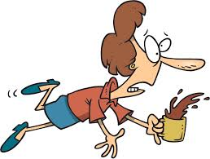 SHE IS / ISN'T CLUMSY.

- 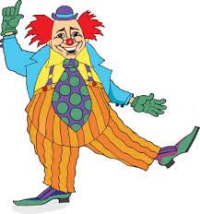 HE IS / ISN'T FUNNY.

- 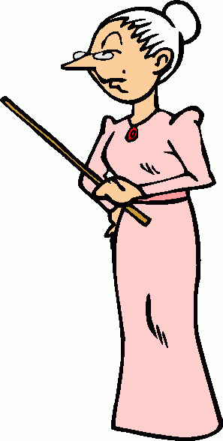 SHE IS / ISN'T NICE. SHE IS / ISN'T STRICT.

- 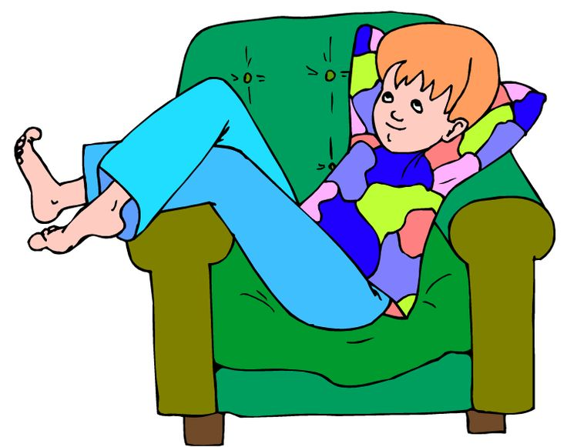 SHE IS / ISN'T LAZY. SHE IS / ISN'T
HARD-WORKING.

