State verbs
When a verb describes a state and not an action we do not use the Continuous tenses.
- 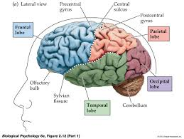 | - 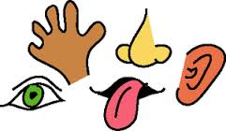
imagine  know  mean  recognize  remember  want  understand  be  think  For instance:  “What do you want?” is CORRECT  “What are you wanting?” is INCORRECT | see  hear  taste  smell  feel  For instance:  “It smells of smoke in here.“ is CORRECT  “It is smelling of smoke in here.“ is INCORRECT | love  like  dislike  prefer  hate  For instance:  “I prefer chocolate ice cream.” is CORRECT  “I am preferring chocolate ice cream.” is INCORRECT | belong  contain  owe  own  have  possess  For instance:  “I owe you £20.” is CORRECT  “I am owing you £20.” is INCORRECT

