**There is something wrong**

**Describe the pictures.**

[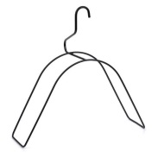](http://www.google.com/url?sa=i&rct=j&q=&esrc=s&source=images&cd=&cad=rja&uact=8&docid=Vc2Vc98VVcdLbM&tbnid=RJzY96NIjTezFM:&ved=0CAUQjRw&url=http://www.surprisinglysane.com/category/sarcasm/&ei=S7zOU9mDPIGeO9GGgdgD&bvm=bv.71198958,d.bGE&psig=AFQjCNEwe4Fs5TfcNt8MZ8axU1P9QDH8lw&ust=1406143927000744)

[](http://www.google.com/url?sa=i&rct=j&q=&esrc=s&source=images&cd=&cad=rja&uact=8&docid=jtYi-Uud4DEGgM&tbnid=VUiVv-oxp2WMoM:&ved=0CAUQjRw&url=http://investingcaffeine.com/2009/11/10/one-size-does-not-fit-all/&ei=trzOU63lBcWsO6XlgdAL&bvm=bv.71198958,d.bGE&psig=AFQjCNGA2dd0GDQuvcDVzVoDyqTvAq0P2w&ust=1406144004673427)

[](http://www.google.com/url?sa=i&rct=j&q=&esrc=s&source=images&cd=&cad=rja&uact=8&docid=58e_q22IgRi1_M&tbnid=ITAcoaCFH_KD5M:&ved=0CAUQjRw&url=http://productivelifeconcepts.com/be-more-creative-its-not-that-hard/&ei=A73OU7WZBMHpPOfYgKAK&bvm=bv.71198958,d.bGE&psig=AFQjCNE1lhY7xmHdvXzBAwafe84Z-YduMg&ust=1406144121122476)

[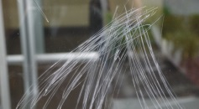](http://www.google.com/url?sa=i&rct=j&q=&esrc=s&source=images&cd=&cad=rja&uact=8&docid=R8BMV0qqZnMmTM&tbnid=-EUtz9WUKswr0M:&ved=0CAUQjRw&url=http://sdglassrestoration.com/portfolio/severe-glass-scratch-removal-in-san-jose-ca/&ei=yr3OU6OYKsiaO-TSgeAP&bvm=bv.71198958,d.bGE&psig=AFQjCNHkg_te45b26zne6mkonEzOJOT5aA&ust=1406144293824442)

[](http://www.google.com/url?sa=i&rct=j&q=&esrc=s&source=images&cd=&cad=rja&uact=8&docid=94DLDYEALaaRKM&tbnid=9Dpd-N-_duIBnM:&ved=0CAUQjRw&url=http://missdress.org/torn-jeans/&ei=Pr7OU9TCM8jHPLzSgeAM&bvm=bv.71198958,d.bGE&psig=AFQjCNHys0qVVKMWfhnii-G_4q4h_FsAUg&ust=1406144432244109)

[](http://www.google.com/url?sa=i&rct=j&q=&esrc=s&source=images&cd=&cad=rja&uact=8&docid=boqxbjVWSI2jPM&tbnid=5dIWZiyeg6BdiM:&ved=0CAUQjRw&url=http://www.funnyfidos.com/uhh-the-door-was-stuck/&ei=Cb_OU_OVIIOhO8HJgUg&bvm=bv.71198958,d.bGE&psig=AFQjCNHGL8-m9M3s-y8ndjv22UBscMIYKQ&ust=1406144578055035)

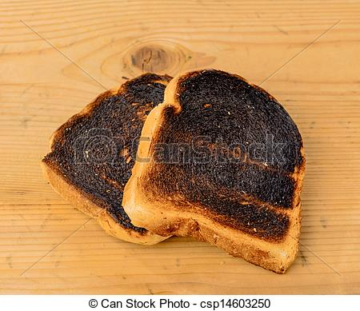

[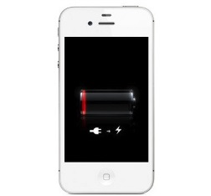](http://www.google.com/url?sa=i&rct=j&q=&esrc=s&source=images&cd=&cad=rja&uact=8&docid=ZjdKR2G_QWoNpM&tbnid=H59Sgyikh4TjPM:&ved=0CAUQjRw&url=http://iphoneaddict.fr/post/news-37477-comparatif-autonomie-de-batterie-9-smartphones-sur-le-banc-dessai&ei=PcDOU7KtCcXrOrWvgIAF&bvm=bv.71198958,d.bGE&psig=AFQjCNEEv6WzcjPUxE8Xvq58HNTMuZcWZg&ust=1406144922071655)

[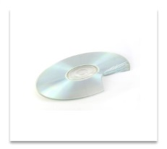](http://www.google.com/url?sa=i&rct=j&q=&esrc=s&source=images&cd=&cad=rja&uact=8&docid=GSN5_q2kqVZlLM&tbnid=SgJpoWIWyd2JaM:&ved=0CAUQjRw&url=http://www.families.com/blog/what-to-do-when-someone-returns-your-stuff-damaged&ei=ecDOU--2JsWROOyggdgC&bvm=bv.71198958,d.bGE&psig=AFQjCNGTMKBak3LjIBt7hpoYuvLGgS2oxQ&ust=1406145007160763)

[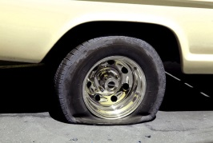](http://www.google.com/url?sa=i&rct=j&q=&esrc=s&source=images&cd=&cad=rja&uact=8&docid=P_nX59DqyjDzxM&tbnid=5A5VBHaDl2ZR7M:&ved=0CAUQjRw&url=http://www.rms.nsw.gov.au/geared/your_car/head_honcho/the_hood_honcho_tyre.html&ei=zsDOU4CJHs2KOIjmgKAO&bvm=bv.71198958,d.bGE&psig=AFQjCNHlg-uMB29jo3nW_zo9lqgMoVI75A&ust=1406145096190787)

[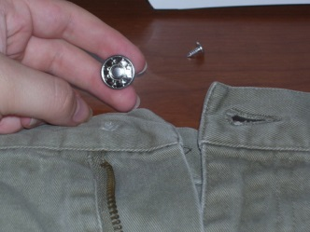](http://www.google.com/url?sa=i&rct=j&q=&esrc=s&source=images&cd=&cad=rja&uact=8&docid=Fdk2cBMxlV-kxM&tbnid=n744PplSja2yfM:&ved=0CAUQjRw&url=http://whitrae.tumblr.com/post/676684849/how-to-fix-a-pants-button&ei=NsHOU72zHsPTOeSVgcgL&bvm=bv.71198958,d.bGE&psig=AFQjCNEoHC7eZaftf76gfeuEjfEnrzalWA&ust=1406145158610185)

[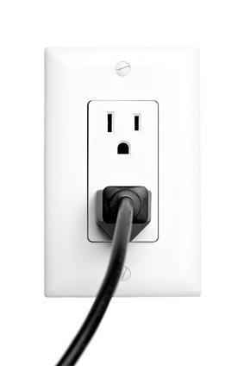](http://www.johnhaydon.com/2010/03/03/embed-seo-automation-wordpress-blog-posts/)

[](http://www.google.com/url?sa=i&rct=j&q=&esrc=s&source=images&cd=&cad=rja&uact=8&docid=VV10gHnP5A69HM&tbnid=oURIRhEMdniPdM:&ved=0CAUQjRw&url=http://finance.zacks.com/homeowners-insurance-pay-replace-broken-windows-6782.html&ei=7cHOU5yXF8LXOcrDgOgB&bvm=bv.71198958,d.bGE&psig=AFQjCNGEjahL2nhhkpQE5BNWLFvZl4STKw&ust=1406145359987942)