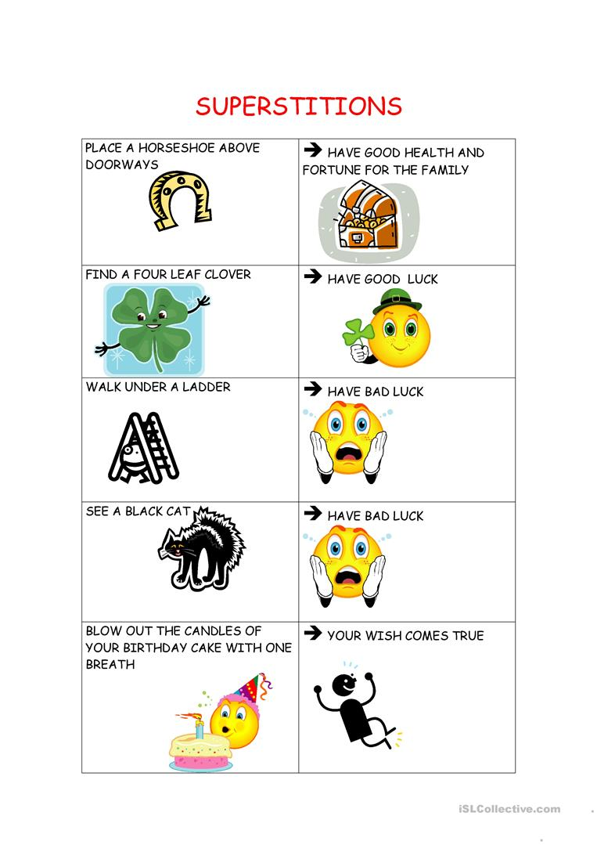
Make sentences:
- If you place a horseshoe………………………………………………. , you will have….

- You will have……………………………………………….if you find……………………………………………

- If ……………………………………………………………………………………………………………………………..

- You will have………………………………………………………………………………………………………………

- If……………………………………………………………………………………………………………………………….

