Kenn Nesbitt
(famous for his poems for children)
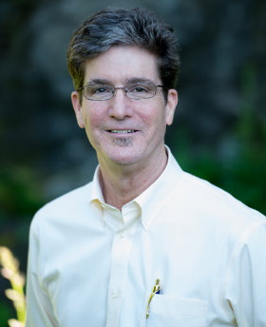
'I am 56 years old and I was born on February 20, 1962 in Berkeley, California. I grew up in Fresno and San Diego, California.
I now live in a big old house in Spokane, Washington, with my wife Ann, our son Max, our daughter Madison, and our cat, Raki.’

