Insects and arachnids
INSECTS | - an ant 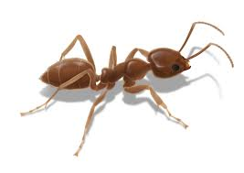 a bee 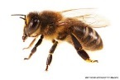  - a praying mantis 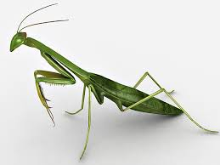 a dragonfly 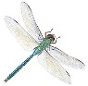
Characteristics | - six legs  - three body parts: a head, a thorax and an abdomen  - wings  - an exoskeleton (i. e. and outer skeleton)
Species | - about 950.000 species of insects
Life cycle | - grow from eggs  - go through various stages – this transformation is called metamorphosis
Metamorphosis  a larva /ˈlɑːvə/ a singular noun  larvae /’la:vi:/ a plural nouns  a pupa /ˈpjuːpə/ a singular noun  pupae /’pju:pi:/ a plural noun | - two kinds of metamorphosis: complete and incomplete  - incomplete: three stages – an egg, a nymph and an adult  - complete metamorphosis:  four stages – an egg, a larva, a pupa and an adult
ARACHNIDS  /əˈræknɪd/ | a scorpion 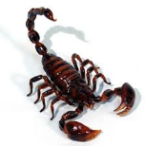 a spider 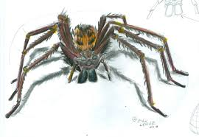
Characteristics | - eight legs  - wings different from those of the insects
Species | - 75.000 (the majority of them spiders)

