Text 4
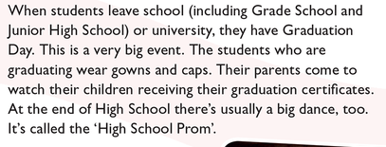

Grade school - osnovna škola
Graduation Day – Dan mature
Gowns and caps – ogrtači i kape
Graduation certificate – diploma
High School Prom – maturalna večer

