We use Simple Future (Will Future) to talk about:

Predictions without evidence | People will live in space stations in the future.  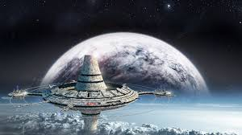  It will be warm and sunny tomorrow. (weather forecast)  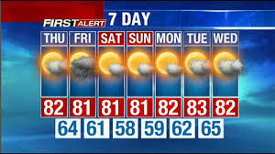
Instant decisions | A: I've left the door open.  B: I will close it.
Offers  Requests | The bag is too heavy for you. I will carry it.  Will you help me to do my homework?
Promises | I will come home at 7 o'clock sharp, I promise.
Future facts | She will be 18 years old next year.  The sun will rise at 6.45 tomorrow.

