**My house**

1. C:\Users\Nina\Desktop\My house.tifWhat rooms are **downstairs**?

Downstairs there is a______________________­­­­­_

­­­­­­­­­­­

2 What rooms are **upstairs**?

Upstairs there are two ____________________________

1. **Put the furniture in the right room?**

KITCHEN SITTING ROOM

|  |
| --- |
|  |
|  |
|  |
|  |
|  |
|  |
|  |
|  |

|  |
| --- |
|  |
|  |
|  |
|  |
|  |
|  |
|  |
|  |

BEDROOM BATHROOM

|  |
| --- |
|  |
|  |
|  |
|  |
|  |
|  |
|  |
|  |

|  |
| --- |
|  |
|  |
|  |
|  |
|  |
|  |
|  |
|  |

DINING ROOM

|  |
| --- |
|  |
|  |
|  |
|  |
|  |
|  |
|  |
|  |

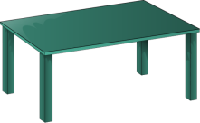  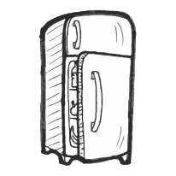 

t_______ c________ f__________ s_____________

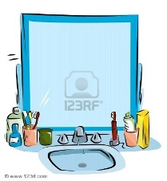 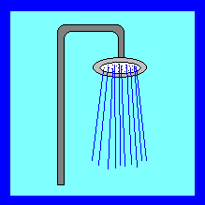 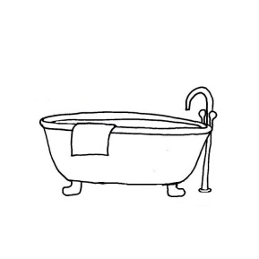 

m_____________ s____________ b________ w ____m _____

and w__________

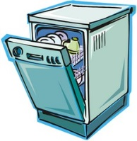 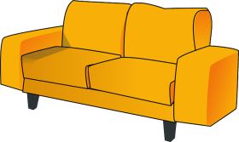 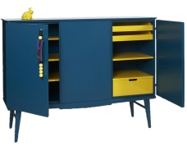 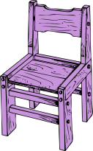

d___________ s______________ c___________ c_________

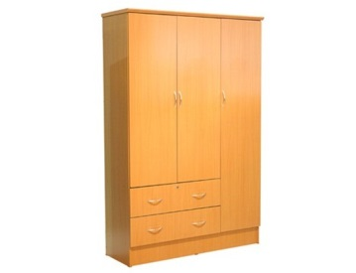  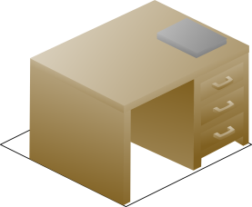 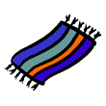

w____________ a____________ d_________ c____________

 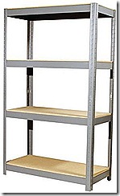 [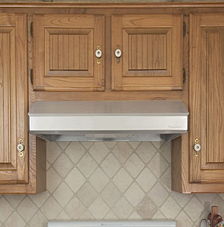](http://www.echelonhomeproducts.ca/products/vent-a-hood/)

b_________________ s ____________ k_______ h_______