**Label the rooms.**

C:\Users\Nina\Desktop\BEDROOM.tif C:\Users\Nina\Desktop\BATHROOM.tif C:\Users\Nina\Desktop\HALL.tif

_____________ ______________ _______________

C:\Users\Nina\Desktop\SITTING ROOM (1).tif C:\Users\Nina\Desktop\SITTING ROOM (2).tif C:\Users\Nina\Desktop\KITCHEN.tif

_______________ ______________ _______________

[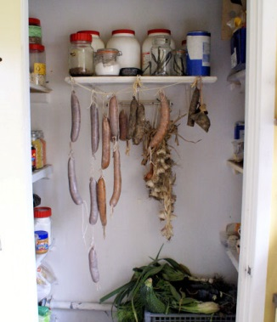](http://www.google.hr/url?sa=i&rct=j&q=&esrc=s&source=images&cd=&cad=rja&uact=8&ved=0ahUKEwj0uIfT97fKAhWLhhoKHbqoAd8QjRwIBw&url=http://forum.downsizer.net/archive/design-student-wants-to-bring-the-larder-to-the-masses__o_t__t_16536.html&psig=AFQjCNF8aUOvov6ixPbnklcvP56HhW6Wuw&ust=1453363613263322)

_________________