Indefinite pronouns
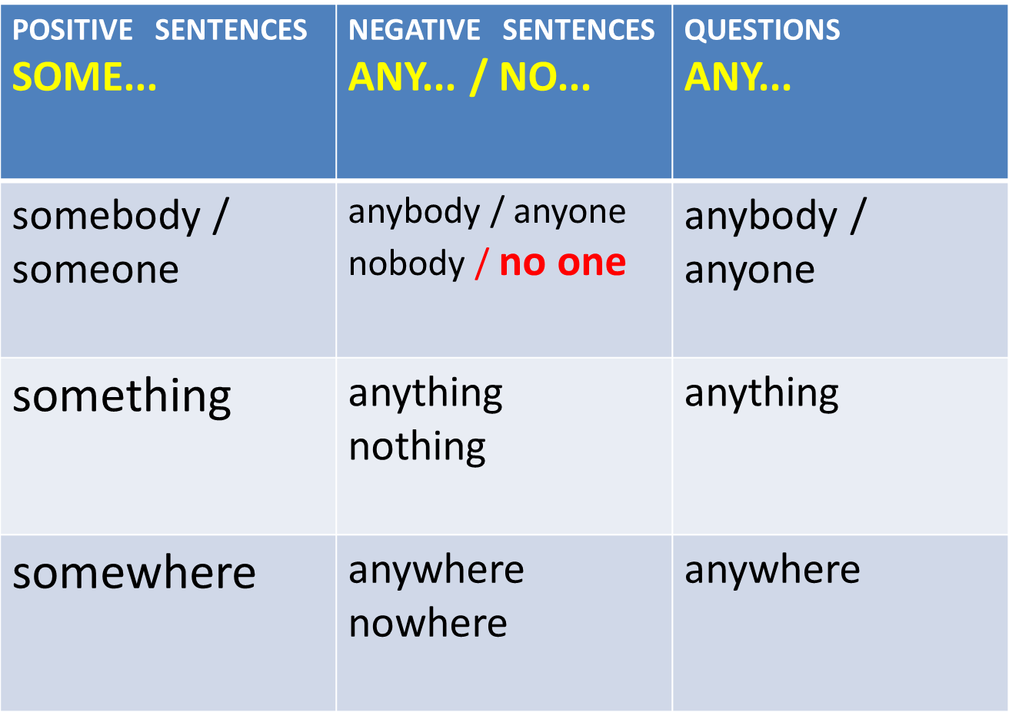
I can see somebody in the street. (positive sentence)
I can't see anybody in the street. (negative sentence)
I can see nobody in the street. (negative sentence: positive verb + nobody)
Can you see anybody in the street? (question)
There is water everywhere.
I can’t say everything. It’s a secret.
Where is everybody?

Use appropriate indefinite pronouns.
- I am sure I put down my keys .........................
- Calm down. There is ........................to worry about.
- Let's sit down ............................and talk.
- I heard a knock at the door but there was ........................there.
- We didn't see .........................
- The restaurant was really crowded. ..........................had a good time.
- Be quite ! ......................is coming.
- I don't think .......................knows the answer to that question.
- She can't go .........................without people recognizing her.
- I've got .......................to tell you.
- I was really bored during the holiday. I did .................and went .......................
- There was water all over the floor. It was ...........................
- There's ............................very attractive about her.
- Did ............................see George Clooney's latest film?
- ..............................is talking about the new soap opera.
- I'm sure there is ...........................downstairs.
- I can't make my point clear. ..........................understands me !

