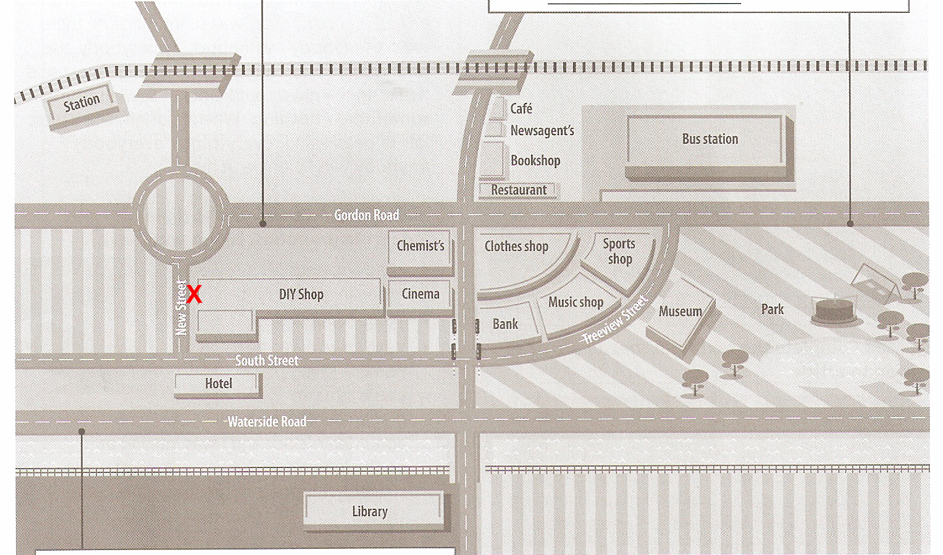

You are in front of the DIY shop.

A: __________, is there a newsagent’s near here?

B: Yes, _______________ till you _________________. __________ at the ______________. Go down there, there is a ____________ on the corner. Take _______________ and the newsagent’s is ___________________, _________ a bookshop and a ________.

