1. Is Peter eleven years old?
2. Is Bristol in the south of England?
3. Are Peter’s sisters and brother older than Peter?
4. Is Peter’s mum busy?
5. Are Dad’s cakes delicious?

f) He likes it very much.

e) They are the same age. They have their birthday on the same day.

1. They are twins.
2. She travels a lot.
3. My neighbour’s dog is cute.
4. Sometimes, they travel together.
5. I like reading.

My name is Peter. My nickname is Pete. I am 11. I live in Bristol with my family. It is a big city in the South West of England. (1) My mum says I am a dreamer. My family is big.   
I have got two sisters and a brother. My sisters are 14. (2) They make me laugh all the time. My brother is older than us. He is a great talker. My mum works in a travel agency. She is hardworking. (3) She likes travelling. My dad is a photographer. He is very brave. (4) My dad is crazy about cooking but he is not good at making cakes. My mum ‘s cakes are delicious.

1. Somebody is funny.
2. Somebody speaks a lot.
3. It is short for Peter.
4. Somebody is busy.

**Find and copy the sentences in Exercise 1 that mean:**

1

**Read the text about Peter. Complete the text with the sentences below. There is one sentence you do not need.**

2

3

**Answer the questions about Peter’s family in Exercise 1. Use: Yes, he/she/it is., No, he/she/it isn’t., Yes, they are., No, they aren’t.**

/ 6

/ 4

/ 5

RAZRED:

NADNEVAK:

UKUPAN BROJ BODOVA:

/ 78

OCJENA:

IME I PREZIME:

UNIT 1 Group A

**Complete with: my, his, her, its, your, their.**

**Match the questions to the answers.**

On holidays in Japan. She is tall and slim.

Very well, I think.

Because it’s my first day here. She’s nice, but shy.

At nine am.

Bananas.

1. What’s Mary like?
2. When do your lessons start?
3. What does Mary like?
4. Why are you shy?
5. Where are your aunt and uncle?
6. How well do you speak English?
7. What does Mary look like?
8. Look at Mike! There is a poster in bag.
9. Ella is Mike’s classmate. task is to speak about Wales.
10. Mike’s school is big but playground is pretty small.
11. Mike and Ella’s geography teacher is nice. history teacher is nice, too.
12. Bob, you have got a poster. Where is poster?
13. I haven’t got a poster. I’ve left poster at home.

Hi! I (1) Mike. I am very busy, so I (2) much time to speak to you. It

(3) polite, I know, but that’s the way things (4) . I (5) a lot of work to do today. It (6) our Project Day at school. You see, I (7) a poster of Scotland in my bag. My friend Bob (8) a lot of postcards from Scotland.   
We (9) shy but we (10) afraid of speaking in front of our classmates.

4

**Complete the text about Mike’s Project Day at school. Use: have got x2, haven’t got, has got, am, is, isn’t, are x2, aren’t.**

5

6

7

**Describe yourself! Use: tall, curly, long, short, slim, green, not slim, dark, wavy, brown, blond(e), blue.**

I am (1) and (2) .

I have got (3) (4) hair. My hair is (5) .

My eyes are (6) .

/ 6

/ 7

/ 6

/ 10

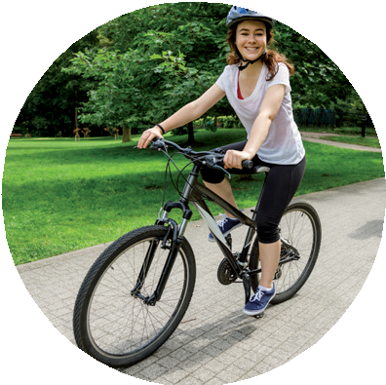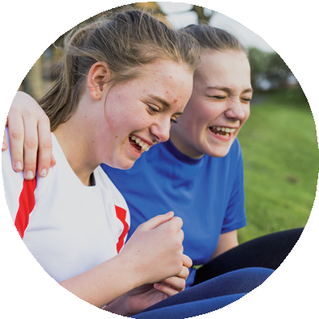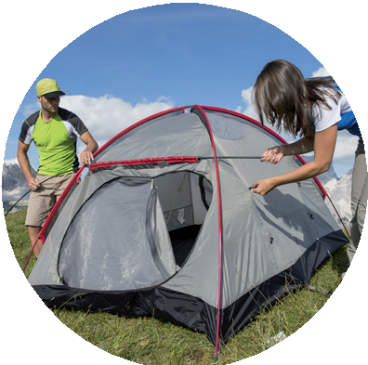

**b) Copy the expressions from Exercise 8 a) under the right picture.**

the piano somebody laugh pasta

a tent high football   
a tree

a bike

**a) Match the expressions.**

8

1. cook
2. climb
3. play
4. make
5. ride
6. put up
7. jump
8. play

e)

a)

f)

b)

g)

c)

h)

d)

/ 8

/ 8

**Complete the table with the plural form of nouns.**

**Whose is it? Complete with ‘s or ‘.**

1. Look at the Parkers house.
2. The first thing you can see is Mum garden. It is beautiful.
3. You can see Mum and Dad car in front of the garage.
4. There are men shoes on the stairs.
5. Mum and Dad computer is in the living room.
6. The children room is upstairs.
7. Charles room is on the left and Julia room is on the right.

9

/ 10

10

/ 8

SINGULAR

a pencil

a watch

a fly

a child

a man

a toy

a kiss

a woman