Unit 1 – revision
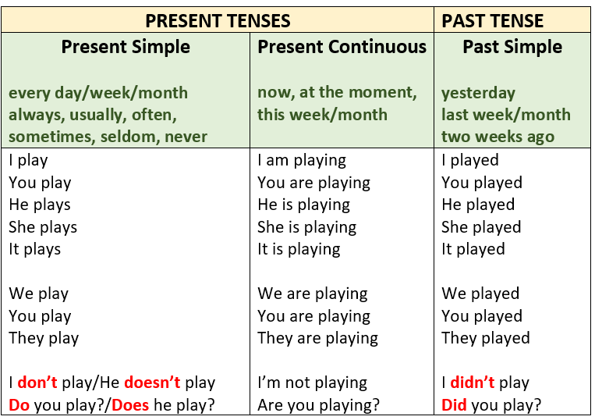
- Present and past tenses
https://www.liveworksheets.com/worksheets/en/English_as_a_Second_Language_(ESL)/Verb_tenses/Present_simple_-_present_continuous_-_past_simple_kh34742ki

C My grammar
https://hr.izzi.digital/DOS/12359/14096.html

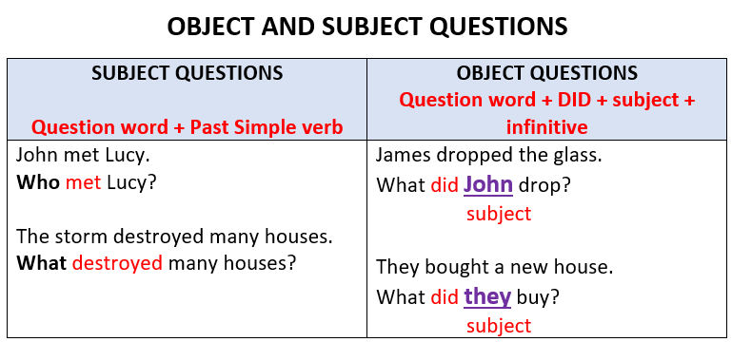
- Subject and object questions
http://www.focus.olsztyn.pl/en-english-exercises-subject-object-questions.html#.X4oJatD7RsI

C My grammar
https://hr.izzi.digital/DOS/12359/14099.html

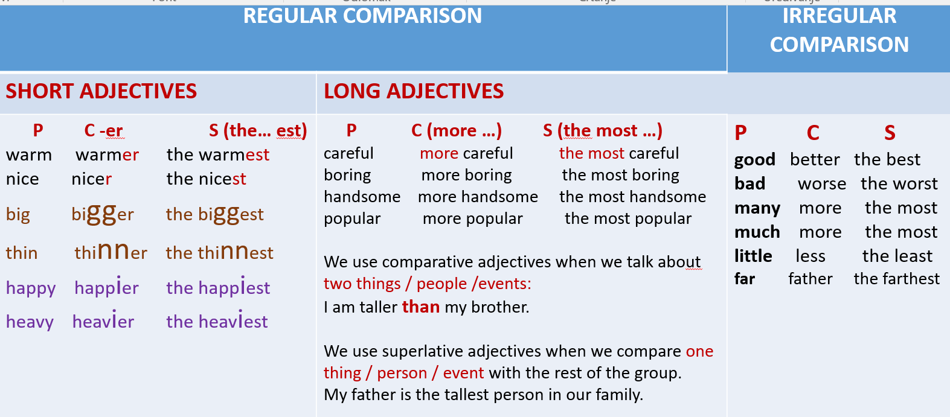

- Comparison of adjectives
https://wordwall.net/play/6136/287/137
https://www.bookwidgets.com/play/VBLWEVY?teacher_id=4814957087555584
B 3
https://hr.izzi.digital/DOS/12359/14102.html

