1
Read about Ben.
Pročitaj o Benu.

Ben is from Vancouver, Canada.
Ben je iz Vancouvera u Kanadi.

People from all over the world live in his hometown.
Ljudi iz cijeloga svijeta žive u njegovom rodnom gradu.

He speaks English, but people in Canada speak French as well.
On govori engleski jezik, ali ljudi u Kanadi govore i francuski jezik.

Canada is a beautiful country with lots of forests, lakes and national parks.
Kanada je prekrasna zemlja s mnogo šuma, jezera i nacionalnih parkova.

Letʼs learn more about Canada!
Naučimo više o Kanadi!
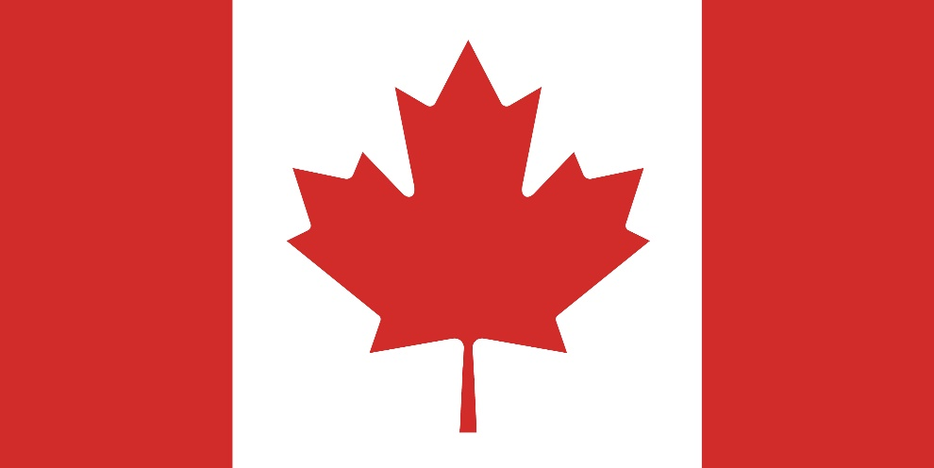

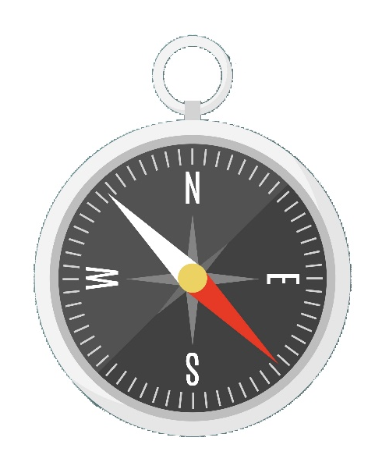
a) Whatʼs in the picture? Circle the correct answer.
2
Što je na slici? Zaokruži točan odgovor.

a) a clock
b) a compass

b) What does this instrument show? Time or direction? Circle the correct
answer.
Što ovaj instrument pokazuje? Vrijeme ili smjer? Zaokruži točan odgovor.

a) time
b) direction

c) Look at the compass in Exercise 2 a). Match the letters with the rest of the words.
Write the words on the line.
Pogledaj kompas u zadatku 2. a). Poveži veliko slovo s ostatkom riječi. Napiši riječi na
crte.
North
1 N | outh | 1 _________________________
2 W  1 | orth | 2 _________________________
3 E | est | 3 _________________________
4 S | ast | 4 _________________________
a) Read the words. Then translate them into Croatian. The words from the box
can help you.
3
Pročitaj riječi. Zatim ih prevedi na hrvatski jezik. Riječi iz kućice mogu ti pomoći.
istok jug kontinent otok glavni grad zapad država sjever

1 North | ____________________________________  sjever
2 South | ____________________________________
3 East | ____________________________________
4 West | ____________________________________
5 continent | ____________________________________
6 country | ____________________________________
7 capital city | ____________________________________
8 island | ____________________________________

b) Look at the map. Read the names of the continents.
Pogledaj kartu. Pročitaj imena kontinenata.
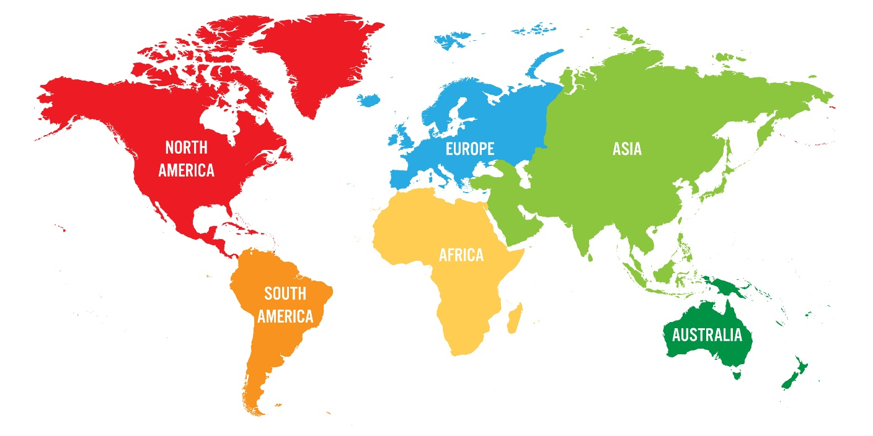

a) Look at the map of Canada. Circle the correct answer.
4
Pogledaj kartu Kanade. Zaokruži točan odgovor.
1 Canada is
Kanada je
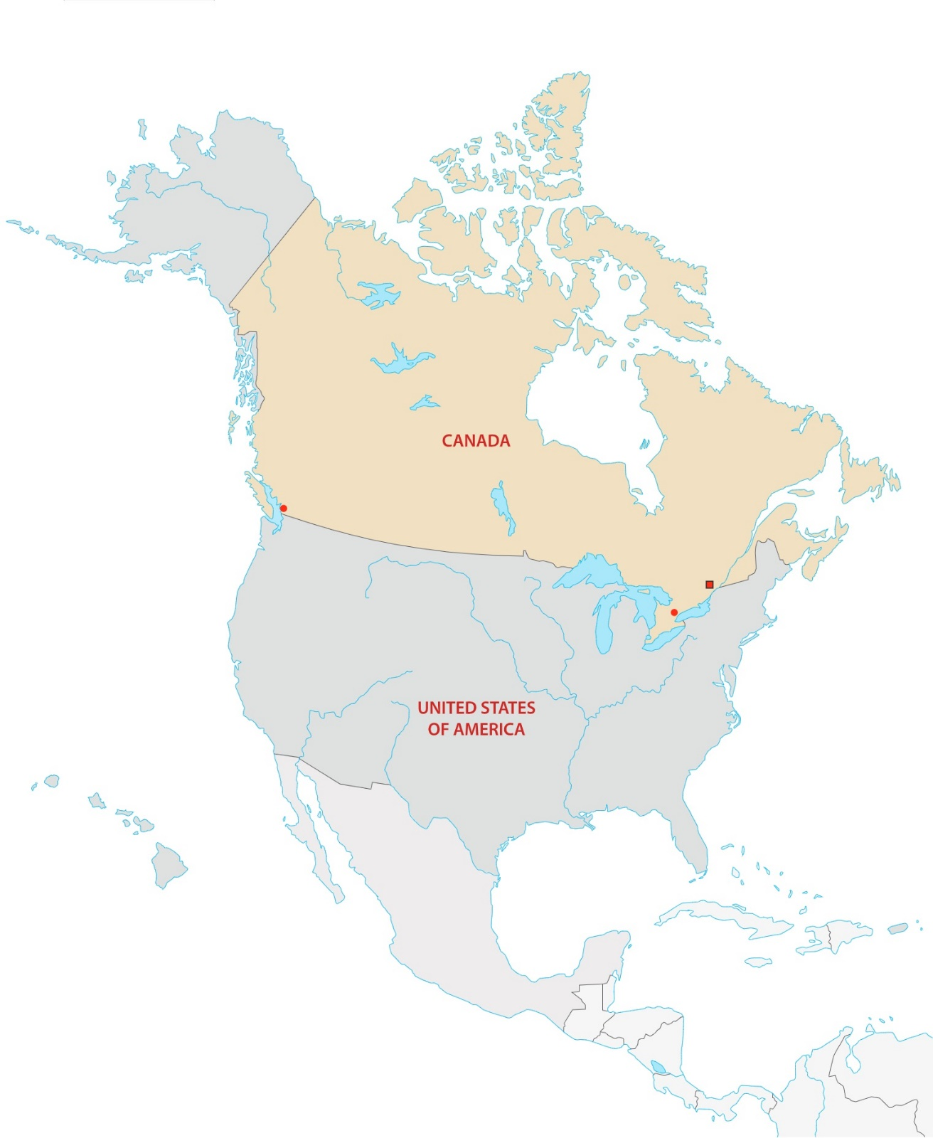
a) a continent.
Toronto
Ottawa
Vancouver
b) a country.
c) an island.

2 Canada is in
Kanada je u
a) Europe.
b) North America.
c) South America.

3 The capital city of Canada is
Glavni grad Kanade je
a) Ottawa.
b) Washington.
c) Edinburgh.
4 The city which is not in Canada is
Grad koji nije u Kanadi je
a) Toronto.
b) Glasgow.
c) Vancouver.
b) Complete the sentences. Exercise 4 a) can help you.
Dopuni rečenice. Zadatak 4. a) može ti pomoći.

1 Canada is a big ________________________.
2 It is in North ________________________.
3 The capital city of Canada is ________________________.
4 ________________ and ________________ are in Canada.

5
a) Write everything you know about Canada in Croatian.
Napiši sve što znaš o Kanadi na hrvatskom jeziku.

1 _______________________________________________________.
2 _______________________________________________________.
3 _______________________________________________________.
4 _______________________________________________________.

b) What do you know about Canada? Report to your teacher in English.
Što znaš o Kanadi? Reci učiteljici na engleskom jeziku.

