1
FOOD FACTS
2AA
a) Look at the pictures. Label them with the words in the box.
Pogledaj slike. Označi ih riječima iz kućice.
potatoes coffee tea tomatoes turkey chocolate

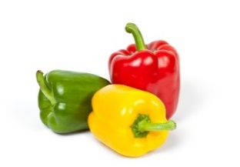 | 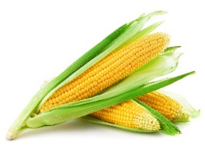 | 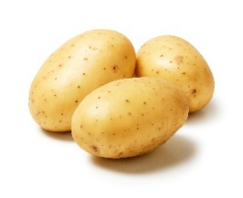 | 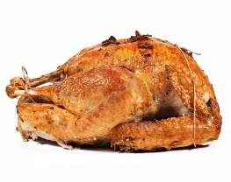
peppers  1 _____________ | maize  2 _____________ | 3 _____________ | 4 _____________
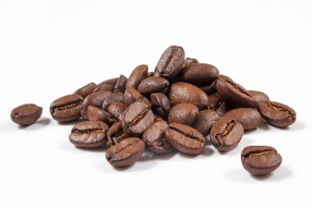 | 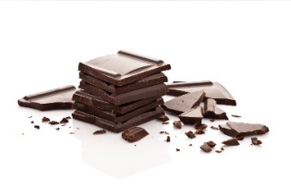 | 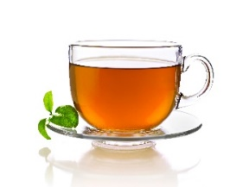 | 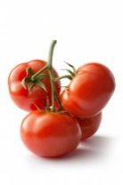
5 _____________ | 6 _____________ | 7 _____________ | 8 _____________

b) Translate the words into English.
Prevedi riječi na engleski jezik.

1 paprike | ________________________________
2 krumpir | ________________________________
3 purica | ________________________________
4 čaj | ________________________________
5 čokolada | ________________________________
6 kava | ________________________________
7 rajčice | ________________________________
8 kukuruz | ________________________________
c) Look at the pictures in Exercise 1 a). Write the sentences and say which
food you like and which food you don’t like.
Pogledaj slike u zadatku 1. a). Napiši rečenice i reci koju hranu voliš, a koju hranu
ne voliš.

1 | I _____________________________________________
2 | I _____________________________________________
2
a) What is it? Look at the pictures Exercise 1 a) again and write the food.
Što je to? Ponovno pogledaj slike u zadatku 1. a) i napiši hranu.

1 It is red. | ________________________________________
2 It is yellow. | ________________________________________
3 It is green. | ________________________________________
4 It is brown. | ________________________________________
5 It is light brown. | ________________________________________

d) Which food do you often eat? Write the food items and their colour on the
lines.
Koju hranu ti često jedeš? Napiši na crte hranu i koje je boje.

 | FOOD | COLOUR
 | ______________________ | ______________________
 | ______________________ | ______________________
 | ______________________ | ______________________
 | ______________________ | ______________________
a) Read the text with your teacher.
3
Pročitaj tekst s učiteljicom.

BEFORE DISCOVERING AMERICA
PRIJE OTKRIĆA AMERIKE
The Europeans didn’t know about some food.
Europljani nisu znali za neku hranu.
They had plenty of cabbage and carrots on their plates.
Imali su puno kupusa i mrkve na svojim tanjurima.
They ate wheat and rice.
Jeli su pšenicu i rižu.
Common people ate a lot of bread and some fish.
Obični ljudi su jeli puno kruha i ribu.
The rich often ate meat.
Bogati su često jeli meso.

AFTER DISCOVERING AMERICA
POSLIJE OTKRIĆA AMERIKE
The Europeans started eating turkey in the 16th (sixteenth) century.
Europljani su počeli jesti puricu u 16. stoljeću.
They brought tomatoes, potatoes and maize from America.
Donijeli su rajčice, krumpire i kukuruz iz Amerike.
They also brought cocoa from America in the 16th century.
Oni su također donijeli kakao iz Amerike u 16. stoljeću.
They started making and eating chocolate in the 19th (nineteenth) century.
Oni su počeli raditi i jesti čokoladu u 19. stoljeću.

b) Are the sentences correct? Circle True or False.
Jesu li rečenice točne? Zaokruži True (točno) ili False (netočno).

1 The Europeans ate turkey in the 15th century.  Europljani su jeli puricu u 15. stoljeću. | True | False
2 They brought some new food from America.  Oni su donijeli novu hranu iz Amerike. | True | False
3 They brought cabbage from America.  Donijeli su kupus iz Amerike. | True | False
4 Common people ate a lot of meat.  Obični ljudi su jeli mnogo mesa. | True | False
5 Tomatoes and potatoes come from America.  Rajčice i krumpiri potječu iz Amerike. | True | False
6 The Europeans ate chocolate in the 19th century.  Europljani su jeli čokoladu u 19. stoljeću. | True | False

c) Read the text again. Write what the Europeans ate before and after discovering
America.
Ponovno pročitaj tekst. Napiši što su Europljani jeli prije i poslije otkrića Amerike.

BEFORE DISCOVERING AMERICA | AFTER DISCOVERING  AMERICA
_________________________ | _________________________
_________________________ | _________________________
_________________________ | _________________________
_________________________ | _________________________
_________________________ | _________________________
_________________________ | _________________________
_________________________

COUNTABLE AND UNCOUNTABLE NOUNS

My…
GRAMMAR!
BROJIVE I NEBROJIVE IMENICE

LOOK AND READ!
POGLEDAJ I PROČITAJ!
Brojive imenice su one koje možemo prebrojati. Mogu biti u jednini i množini.
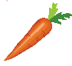  a tomato a carrot  jednina | two tomatoes four carrots  množina
Nebrojive imenice ne možemo brojati. Imenice imaju samo oblik jednine.
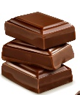

water chocolate rice
voda čokolada riža

4
a) Look at the pictures. Which food and drinks can you count? Label each group
with Countable nouns or Uncountable nouns.
Pogledaj slike. Koju hranu i piće možeš brojiti? Označi svaku grupu s Brojive
imenice ili Nebrojive imenice.
nouns  ________________________ | nouns  ________________________
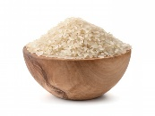  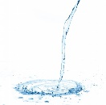  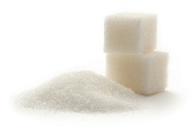  water  sugar  rice  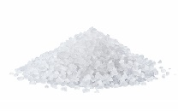  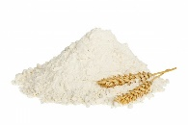  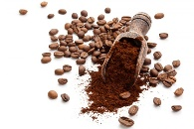  flour  salt  coffee | 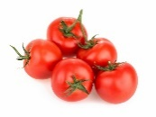  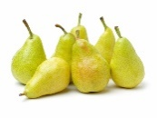  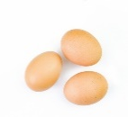  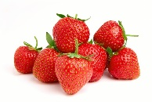  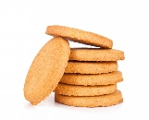  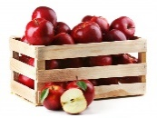  pears  strawberries  biscuits  apples  eggs  tomatoes
b) Write the singular form of the countable nouns from Exercise 4 a).
Napiši jedninu brojivih imenica iz zadatka 4. a).
a strawberry
1 strawberries | ________________________
2 eggs | ________________________
3 tomatoes | ________________________
4 pears | ________________________
5 apples | ________________________
6 biscuits | ________________________

c) Are the nouns below countable (C) or uncountable (U)? Label them with C or U.
Jesu li imenice u zadatku ispod brojive ili nebrojive? Označi ih sa C ili U.
C
1 tea | ____ |  | 5 apple | ____
2 carrot | ____ |  | 6 meat | ____
3 coffee | ____  U |  | 7 potato | ____
4 chocolate | ____ |  | 8 chicken | ____
5
Use some of the words from Exercise 4 a) in the sentences of your own. Write about how often you eat certain food or drink certain drinks. Report to your teacher.
Upotrijebi neke riječi iz zadatka 4. a) u svojim rečenicama. Napiši koliko često jedeš neku hranu ili piješ neka pića. Reci učiteljici.
I drink water every day.
1 ______________________________________________.
2 ______________________________________________.
3 ______________________________________________.
4 ______________________________________________.
5 ______________________________________________.

