- This is a healthy lifestyle. Ovo je zdrav stil života.

- This is an unhealthy lifestyle.
Ovo je nezdrav stil života.

  - This is a healthy lifestyle. Ovo je zdrav stil života.

  - This is an unhealthy lifestyle. Ovo je nezdrav stil života.

a) Match

and read.

Poveži i pročitaj.

2

- do sport jesti prerađenu hranu

Look at the pictures and circle the correct answer.

Explain why in Croatian.

Pogledaj
slike i zaokruži točan odgovor. Objasni

zašto

na hrvatskom jeziku
.

1

3
A
FOOD FOR THOUGHT

1

- do gardening provoditi vrijeme ispred ekrana
- spend time outdoors jesti masnu hranu
- eat processed food baviti se sportom
- eat fatty food raditi u vrtu
- cook with fresh ingredients kuhati sa svježim namirnicama
- spend time indoors provoditi vrijeme na otvorenom
- spend time in front of the screen provoditi vrijeme u zatvorenom

b) Translate the phrases into English.
Prevedi fraze na engleski jezik.

- jesti prerađenu hranu _______________________________
- jesti masnu hranu _______________________________
- baviti se sportom _______________________________
- raditi u vrtu _______________________________
- kuhati sa svježim namirnicama _______________________________
- provoditi vrijeme na otvorenom _______________________________
- provoditi vrijeme u zatvorenom _______________________________
- provoditi vrijeme ispred ekrana _______________________________
____________________________________

c) Sort out the phrases in English. What is healthy, and what unhealthy for people?
Razvrstaj fraze na engleskom jeziku. Što je zdravo, a što nezdravo za ljude?
HEALTHY UNHEALTHY zdravo nezdravo
- __________________________ ___________________________
- __________________________ ___________________________
- __________________________ ___________________________
- __________________________ ___________________________

d) Write three things that you often, sometimes or never do.
Napiši tri stvari koje radiš često, ponekad ili nikad ne radiš.

- I often ________________________________________________.
- I sometimes ___________________________________________.
- I never _______________________________________________ .

a) Read about Carl,

Zo
e

and Antoine
.

P
r
očitaj o
Carlu, Zo
e

i Antoin
e
u
.

3

I often eat too many sweets and junk food.
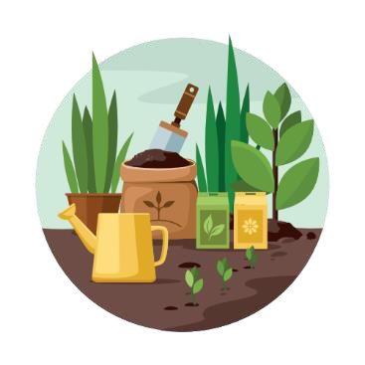
Često jedem previše slatkiša i nezdrave hrane.
I have some weight problems.
Imam problema s težinom.
I don’t do any sports.
Ne bavim se nikakvim sportom.
That’s why I am doing some gardening now.
Zato sada radim u vrtu.
In this way I am spending time outdoors and helping my parents.
Na taj način provodim vrijeme na otvorenom i pomažem svojim roditeljima. Carl,12

I often eat processed food, and I want to change it.
Često jedem prerađenu hranu i želim to promijeniti. That’s why I am learning to cook now!
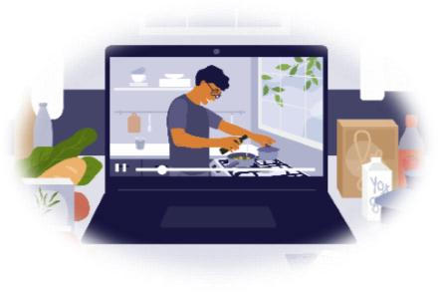
Zato sada učim kuhati!
I am using simple, fresh ingredients.
Koristim jednostavne, svježe namirnice.
I don’t eat fatty food.
Ne jedem masnu hranu.
It is never too early to learn to cook and start watching your diet.
Nikad nije prerano učiti kuhati i početi paziti na svoju prehranu.
Antoine,15
I spend a lot of time indoors.
Provodim dosta vremena u zatvorenom prostoru.
I play video games every day.
Igram videoigrice svaki dan.
I know it’s not good for my health.
Znam da to nije dobro za moje zdravlje.
So I am experimenting with new activities.
Zbog toga eksperimentiram s novim aktivnostima.
At the moment I am learning to play the drums.
Trenutno učim svirati bubnjeve.
I am trying something new these days.
Pokušavam nešto novo ovih dana.
Zoe, 12

- Read the text again and answer the questions. Circle the correct name.
Pročitaj tekst ponovo i odgovori na pitanja. Zaokruži točno ime.

1 Who is playing an instrument?  Tko svira instrument? | Carl | Antoine | Zoe
2 Who is helping others?  Tko pomaže drugima? | Carl | Antoine | Zoe
3 Who is watching his diet? | Carl | Antoine | Zoe
Tko pazi na svoju prehranu?

- Who is talking? Read the sentences, and write the correct name on the line.
Write: Carl, Antoine or Zoe. Exercise 3 a) can help you.
Tko govori? Pročitaj rečenice i napiši točno ime na crtu. Napiši: Carl, Antoine ili Zoe.
Zadatak 3. a) može ti pomoći.

1 I am trying something new these days.  Pokušavam nešto novo ovih dana. | ________________
2 I often eat too many sweets and junk food.  Često jedem previše slatkiša i nezdrave hrane. | ________________
3 It is never too early to learn to cook.  Nikad nije prerano učiti kuhati. | ________________
4 I play video games every day.  Igram videogrice svaki dan. | ________________
5 I am doing some gardening now.  Sada radim u vrtu. | ________________
6 I am learning to cook now.  Sada učim kuhati. | ________________
7 At the moment I am learning to play the drums. | ________________

Trenutno učim svirati bubnjeve.

GRAMMAR! PRESENT SIMPLE VS PRESENT CONTINUOUS

Kada upotrijebiti present simple, a kada present continuous?

LOOK AND READ!
POGLEDAJ I PROČITAJ!
PRESENT SIMPLE PRESENT CONTINUOUS
I rarely do sports. I am doing some gardening now.
Rijetko se bavim sportom. Radim u vrtu sada.
I often eat processed food. I am cooking now.
Često jedem prerađenu hranu. Kuham sada.
Every day I watch TV for a few hours. I am spending more time outdoors these days.
Svaki dan gledam TV po nekoliko sati. Provodim više vremena vani ovih dana.

- Read the sentences carefully. Pay attention to the coloured words. Circle the correct verb tense.
Pažljivo pročitaj rečenice. Obrati pažnju na obojene riječi. Zaokruži točno glagolsko vrijeme.

  - Carl rarely does / is doing any sports.
  - He helps / is helping his parents in the garden these days.
  - He works / is working in the garden now.
  - My brothers watch / are watching TV every day.
  - They often play / are playing video games.
  - They never spend / are spending time outdoors.

- Listen to Ben’s mum. Read the sentences and tick (✓) the correct answeres
Poslušaj Benovu mamu. Pročitaj rečenice i kvačicom označi (✓₎ točne odgovore.

I am Ben's mum. I go to work every day. I come home at 7 o'clock. It is Saturday. We are all at home now. We are spending time together. I am cooking dinner and Ben is helping me.

    - Ben’s mum goes to work every day. ____________
    - She comes home at 5 o’clock. ____________
    - It is Sunday. ____________
    - Mum is cooking dinner. ____________
    - Ben isn’t helping his mum. ____________

