1

a) Read with your teacher or with your friend.

Pročitaj s učiteljicom ili prijateljem / prijateljicom.
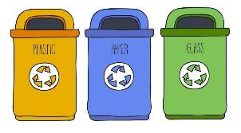
1 waste bins | 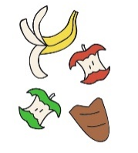 | kante za otpad
2 food leftovers | 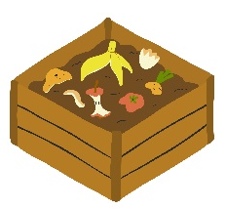 | ostatci hrane
3 composting |  | kompostiranje
4 cloth bag | 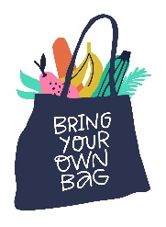 | platnena torba
5 tap water | 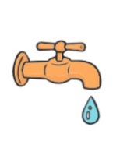 | voda iz slavine
6 take a shower | 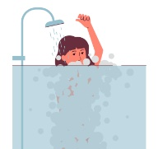 | tuširati se
7 take a bath | 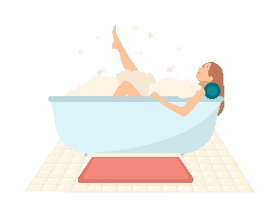 | kupati se
8 turn off the water | 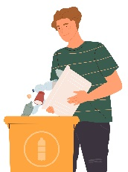  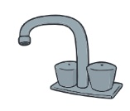 | zatvoriti vodu
9 recycle waste |  | reciklirati otpad
10 be eco-friendly |  | brinuti se o okolišu

b) Translate the words and expressions into English.
Prevedi riječi i izraze na engleski jezik.
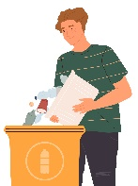
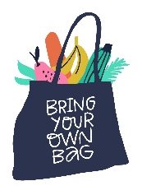
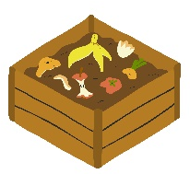
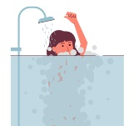
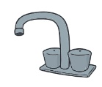
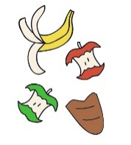
be eco-friendly
1 brinuti se o okolišu | _____________________________
2 zatvoriti vodu | _____________________________
3 tuširati se | _____________________________
4 kompostiranje | _____________________________
5 platnena torba | _____________________________
6 kante za otpad | _____________________________
7 voda iz slavine | _____________________________
8 reciklirati otpad | _____________________________
9 ostatci hrane | 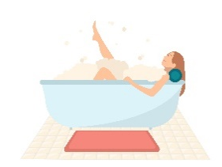  _____________________________
10 kupati se | _____________________________

2
a) Read the text to your teacher. Circle the words from Exercise 1 b) in red.
Pročitaj tekst učiteljici. Zaokruži riječi iz zadatka 1. b) crveno.

Sophie and her family are eco-friendly.
Sophie i njezina obitelj se brinu o okolišu.
They recycle waste.
Oni recikliraju otpad.
Their neighbour, Mrs Doyle, wants to be more eco-friendly, too.
Njihova susjeda, gđa Doyle, se također želi više brinuti o okolišu.
She has got separate waste bins for paper, plastic, metal and glass.
Ona ima posebne kante za otpad za papir, plastiku, metal i staklo.
She asks Sophie what else she can do.
Pita Sophie što još može napraviti.
Sophie tells her she can use food leftovers for composting.
Sophie joj kaže da može koristiti ostatke hrane za kompostiranje.
She can also use a cloth bag when she goes shopping.
Također može koristiti platnenu torbu kad ide u kupovinu.
She can drink tap water.
Može piti vodu iz slavine.
She can take a shower.
Može se tuširati.
She can turn off the water when she brushes her teeth.
Može ugasiti vodu kada pere zube.
That way she can save water.
Na taj način može uštedjeti vodu.

b) Match the words. Then copy them on the lines.
Poveži riječi. Zatim ih prepiši na crte.
waste bins

1 waste  1 | leftovers | 1 _________________________________
2 tap | bins | 2 _________________________________
3 food | bag | 3 _________________________________
4 cloth | water | 4 _________________________________
c) Read the question. Then complete the answers with the words from the box.
Pročitaj pitanje. Zatim dopuni odgovore riječima iz kućice.
recycle turn off save take drink

What can Sophieʼs neighbours do to become eco-friendly?
Što Sophieini susjedi mogu učiniti da počnu voditi brigu o okolišu?
drink
1 They can __________________ tap water.
Mogu piti vodu iz pipe.
2 They can __________________ a shower.
Mogu se tuširati.
3 They can __________________ the water when they brush their teeth.
Mogu ugasiti vodu kada peru zube.
4 They can __________________ water.
Mogu štedjeti vodu.
5 They can __________________ waste.
Mogu reciklirati otpad.

VERB CAN
GLAGOL MOĆI

LOOK AND READ! | POGLEDAJ I PROČITAJ!
I can drink tap water. | Mogu piti vodu iz pipe.
I canʼt drink rainwater. | Ne mogu piti kišnicu.
Can you save water?  Yes, I can.  No, I canʼt. | Možeš li štedjeti vodu?  Da, mogu.  Ne, ne mogu.
3
Complete the sentences with can or canʼt.
Dopuni rečenice s can ili canʼt.
can
1 I _____________ use a cloth bag for shopping.
Mogu koristiti platnenu torbu za kupovinu.
2 My baby brother _____________ make compost.
Moj mali brat ne može raditi kompost.
3 The children _____________ save water when they brush their teeth.
Djeca mogu štedjeti vodu kad peru zube.
4 We _____________ drink tap water.
Možemo piti vodu iz slavine.
5 You _____________ drink rainwater.
Ti ne možeš piti kišnicu.

4
a) Interview your friend. Tick (✓) three things he / she can do to protect the
nature. Cross out (x) the things he / she canʼt do.
Intervjuiraj prijatelja / prijateljicu. Kvačicom (✓) označi tri stvari koje on / ona može napraviti kako bi zaštitio / zaštitila okoliš. Stavi križić (x) pored stvari koje on / ona ne može napraviti.

1 Can you drink tap water?
2 Can you turn off the TV when you go to school?
3 Can you drink rainwater?
4 Can you have a big garden?
5 Can you walk to school?
b) Copy the sentences about your friend on the lines.
Prepiši rečenice o tvom prijatelju / tvojoj prijateljici na crte.
1 He / She can ____________________________________________.
2 He / She can ____________________________________________.
3 He / She can ____________________________________________.
4 He / She canʼt ___________________________________________.
5 He / She canʼt ___________________________________________.

c) Report to your teacher.
Reci učiteljici što si saznao / saznala.

