3CA
HAPPINESS IS…
1
a) Look at the words and pictures. Repeat after your teacher. Then copy the words
in English on the empty lines.
Pogledaj riječi i slike. Ponovi riječi za učiteljicom. Zatim prepiši engleske riječi na
prazne crte.
1 proud |  | ________________________ | ponosan
2 frightened |  | ________________________ | prestrašen
3 calm |  | ________________________ | miran
4 angry |  | ________________________ | ljut
5 jealous |  | ________________________ | ljubomoran
6 grumpy |  | ________________________ | mrzovoljan

b) Translate the words into English. Read them to your teacher.
Prevedi riječi na engleski jezik. Pročitaj ih učiteljici.

1 ljut | _______________________________________
2 miran | _______________________________________
3 ponosan | _______________________________________
4 prestrašen | _______________________________________
5 ljubomoran | _______________________________________
6 mrzovoljan | _______________________________________

c) Match the pictures with the words.
Poveži slike i riječi.
1 calm
2 angry
3 grumpy
4 frightened
1
5 jealous
6 proud

d) Fill in the missing letters. Then read the words and translate them.
Dopuni slova koja nedostaju. Zatim pročitaj riječi i prevedi ih.
1 c__ lm | 4 gr __ mpy
2 j__ __ l__us | 5 __ ngr__
3 pr__ __ d | 6 fr __ ght__ n __d

2
a) Write how you often, sometimes or never feel. Complete the sentences.
Napiši kako se često ili ponekad osjećaš, ili kako se nikad ne osjećaš. Nadopuni rečenice.

1 I am often ___________________________________________.
2 I am sometimes ______________________________________.
3 I am never __________________________________________.

b) Think of your mum. How does she feel in these situations?
Razmisli o svojoj mami. Kako se ona osjeća u ovim situacijama?

1 You help your mum at home. She is p_________.
Pomažeš mami kod kuće.
2 She doesn't know where you are. She is f___________.
Ona ne zna gdje si.
3 The whole family is at home, watching TV. She is c___________.
Cijela obitelj je kod kuće, gleda televiziju.
4 The house is in a mess. She is a___________.
Kuća je u neredu.
5 She has a hard day at work. She is g___________.
Ima težak dan na poslu.

GERUND

My…
GRAMMAR!
GERUND (glagolska imenica)
Gerund je glagolska imenica, ili imenica koju tvorimo od glagola.

LOOK AND READ!
glagol | + -ing | glagolska imenica
spend | -ing = | spending
provoditi |  | provođenje
spending time in nature provođenje vremena u prirodi

make | -ing = | making
raditi,pripremati |  | rađenje, pripremanje
making breakfast together pripremanje doručka zajedno

learn | -ing = | learning
učiti |  | učenje
learning new things učenje novih stvari

be | -ing = | being
biti |  | bivanje
being lazy ljenčarenje

Gerund tvorimo dodavanjem nastavka –ing na glagol.
Često ga koristimo iza glagola like (sviđati se) ili love (voljeti).

I love spending time in nature.
Ja volim provođenje vremena u prirodi.
She likes swimming in the sea.
Njoj se sviđa plivanje u moru.
a) What is happiness? Look at the pictures. Write what makes these people happy.
Use the phrases from the box.
3
Što je sreća? Pogledaj slike. Napiši što usrećuje ove ljude. Koristi izraze iz kućice.
learning new things spending time in nature
being lazy making breakfast together

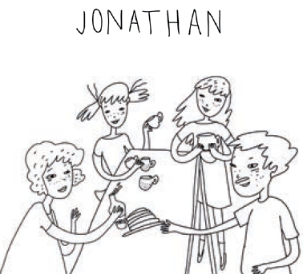  making breakfast together | 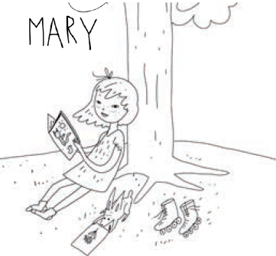
1 ___________________________ | 2 ___________________________
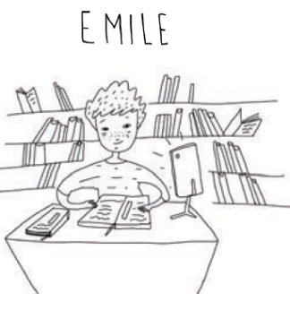 | 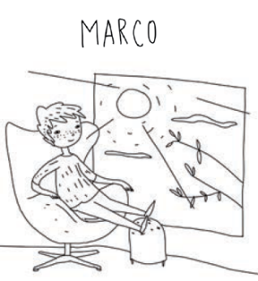
3 ___________________________ | 4 ___________________________

b) Look at the pictures again. Write full answers. What makes them happy?
Pogledaj ponovo slike. Napiši pune odgovore. Što ih usrećuje?
Making breakfast together
1 _________________________ makes Jonathan happy.
2 _________________________________________________________
3 _________________________________________________________
4 _________________________________________________________
4
Listen to what makes Mary happy. Circle YES or NO.
Poslušaj što usrećuje Mary. Zaokruži YES (da) ili NO (ne).
I like spending time outdoors. Roller-skating is my favourite
free-time activity. I like spending time in nature. Being in nature is very relaxing.

1 She likes spending time indoors. | YES | NO
2 She likes roller-skating. | YES | NO
3 She doesn’t like spending time in nature. | YES | NO
4 Being in nature is very relaxing. | YES | NO
5
What about you? Write and draw.
A ti? Napiši i nacrtaj.

Who makes you happy? What makes you happy?
Tko te usrećuje? Što te usrećuje?

