1
TRAVELLING BACK IN TIME
3BA
a) Look at the periods of history and the Croatian names for these periods.
Read the words with your friend. Try to remember as many periods as possible.
Pogledaj razdoblja u povijesti i hrvatska imena za ta razdoblja. Pročitaj riječi sa svojim prijateljem / svojom prijateljicom. Pokušaj zapamtiti što je više razdoblja moguće.

1 Bronze Age | Brončano doba
2 Ancient Egypt | Stari Egipat
3 Ancient Greece | Stara Grčka
4 Roman Empire | Rimsko carstvo
5 Ottoman Empire | Otomansko carstvo
6 Mayan civilization | Civilizacija Maja
7 The great geographical discoveries | Velika zemljopisna otkrića

b) Copy the English names of the periods of history. Tick (✓) the periods which
were most interesting to you during your history lesson.
Prepiši imena povijesnih razdoblja na engleskom jeziku. Stavi kvačicu (✓) pokraj
razdoblja koja su ti bila najzanimljivija na satovima povijesti.

1 ______________________________________________ | ___
2 ______________________________________________ | ___
3 ______________________________________________ | ___
4 ______________________________________________ | ___
5 ______________________________________________ | ___
6 ______________________________________________ | ___
7 ______________________________________________ | ___
c) Match the words with the historic periods.
Poveži riječi s povijesnim razdobljima.

1 Ancient Greece | ___  1 | America
2 Roman Empire | ___ | philosopher
3 Ancient Egypt | ___ | wheel
4 Bronze Age | ___ | pyramid
5 The great geographical discoveries | ___ | arena
2
a) Read what period Raj and his friends would travel back to if time travel were
possible.
Pročitaj u koje bi se razdoblje Raj i njegovi prijatelji vratili kad bi putovanje u prošlost
bilo moguće.

I really wish that time travel was possible.
Stvarno bih želio da je putovanje kroz prošlost moguće.
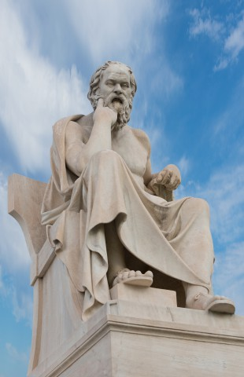
I like watching documentaries about history,
Volim gledati dokumentarce o povijesti,
especially about Greek philosophers.
osobito o grčkim filozofima.
That’s why I would like to talk to Plato or Aristotle
Zato bih volio razgovarati s Platonom ili Aristotelom
and go back to Ancient Greece.
i vratiti se u Staru Grčku.
Eric,12

I would like to go back to the time of Columbus.
Ja bih se volio vratiti u vrijeme Kolumba.
Columbus believed he found a new way to India.
Kolumbo je vjerovao da je pronašao novi put u Indiju.
It was not the new way to India. He discovered America.
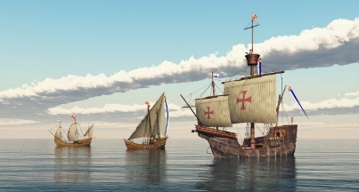
To nije bio novi put u Indiju. On je otkrio Ameriku.
I wish I was on board of his ship.
Želio bih da sam bio na palubi njegova broda.
Raj, 12

I would like to visit Ancient Egypt and
Voljela bih posjetiti Stari Egipat i
solve the mystery of how Egyptians built their pyramids.
riješiti tajnu kako su Egipćani sagradili svoje piramide.
I would like to help build the statue of Sphinx.
Voljela bih pomoći izgraditi kip Sfinge.
I would be happy to draw some hieroglyphs on the wall.
Bila bih sretna kad bih nacrtala neke hijeroglife na zidu.
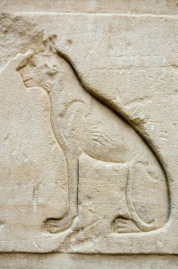
Egyptians loved their cats.
Egipćani su voljeli svoje mačke.
I love cats, too.
Ja također volim mačke.
Ellie, 13

b) Are the sentences correct? Circle True or False.
Jesu li rečenice točne? Zaokruži True (točno) ili False (netočno).

1 Plato was a Greek philosopher.  Platon je bio grčki filozof. | True | False
2 Greeks loved their cats.  Grci su voljeli svoje mačke. | True | False
3 Columbus discovered India.  Columbus je otkrio Indiju. | True | False
4 Eric would like to talk to Greek philosophers.  Eric bi želio razgovarati s grčkim filozofima. | True | False
5 Raj would like to solve the mystery of the pyramids.  Raj bi želio riještiti tajnu pramida. | True | False
6 Columbus wanted to find a new way to India.  Columbus je želio pronaći novi put za Indiju. | True | False

c) Copy the words from the box next to the correct word to get the phrase
that means the same as the Croatian phrase.
Prepiši riječi iz kućice pokraj točne riječi da bi dobio / dobila izraze koji imaju isto
značenje kao izrazi na hrvatskom jeziku.

the mystery a way build a continent hieroglyphs
1 solve | ___________________ | riješiti tajnu
2 help | ___________________ | pomoći izgraditi
3 draw | ___________________ | crtati hijeroglife
4 discover | ___________________ | otkriti kontinent
5 find | ___________________ | pronaći put

d) Complete the sentences.
Dopuni rečenice.
1 Eric would like to go to _________________________________.
Eric bi želio ići …
2 Raj would like to go to __________________________________.
Raj bi želio ići…
3 Ellie would like to go to _________________________________.
Ellie bi željela ići…
3
a) Which of the two sentences in each in each pair sounds more polite? Tick (✓)
the more polite one.
Koja od dvije rečenice u svakom paru zvuči uljudnije? Stavi kvačicu (✓) pokraj
pristojnije rečenice.

 | I would like to travel to the past.  Volio bih putovati u prošlost. |  | I want to travel to the past.  Želim putovati u prošlost.
 | I’d like to talk to Plato.  Volio bih razgovarati s Platonom. |  | I want to talk to Plato.  Želim razgovarati s Platonom.
I would like = I’d like

b) Read the texts again. For each child, write one reason why they would like to go
to that period.
Ponovo pročitaj tekstove. Za svako dijete napiši jedan razlog zašto bi voljeli ići u to
razdoblje.

1 Eric would like to _______________________________________.
2 Raj would _____________________________________________.
3 _____________________________________________________.
a) Think about your future. Answer the questions. Find a picture to illustrate
something from your future.
4
Razmisli o svojoj budućnosti. Odgovori na pitanja. Pronađi sliku koja prikazuje
nešto iz tvoje budućnosti.

1 Where would you like to live?
Gdje bi želio / željela živjeti?
_______________________________________________________.
2 Would you like to travel?
Bi li želio / željela putovati?
________________________________________________________.
3 Where would you like to go?
Gdje bi želio / željela ići?
_______________________________________________________.
4 Would you like to solve a mystery?
Bi li želio / željela riješiti neku tajnu?
_______________________________________________________.

b) Tell your teacher what you would like to do in your future.
Reci svojoj učiteljici što bi želio / željela raditi u budućnosti.

