WHERE WERE YOU?
1AA
1
a) Do you remember the days of the week? Match and read.
Sjećaš li se dana u tjednu? Poveži i pročitaj.

 | 1 Thursday |  | petak
 | 2 Tuesday |  | ponedjeljak
 | 3 Sunday | 1 | četvrtak
 | 4 Wednesday |  | subota
 | 5 Saturday |  | srijeda
 | 6 Friday |  | utorak
 | 7 Monday |  | nedjelja

b) Read and translate the words.
Pročitaj i prevedi riječi.
prošle nedjelje
1 last Sunday | ______________________________________________  prošlog tjedna
2 last week | ______________________________________________  godine
3 last year | ______________________________________________  jučer
4 yesterday | ______________________________________________
5 last Wednesday | ______________________________________________
6 last Tuesday | ______________________________________________
7 last Thursday | ______________________________________________

a) Read the sentences. Tick (✓) those you would like to hear from your friends.
2
Pročitaj rečenice. Označi kvačicom (✓) one koje bi volio/voljela čuti od svojih prijatelja.
1 Welcome back! | ___ | Dobro došao/došla natrag!
2 Good to see you. | ___ | Dobro te je vidjeti.
3 I was ill. | ___ | Bio/bila sam bolesna.
4 I was in bed. | ___ | Bio/bila sam u krevetu.
5 It was a bad cold. | ___ | Bila je jaka prehlada.
6 I'm glad you are feeling better. | ___ | Drago mi je da se osjećaš bolje.
7 We were at a science museum. | ___ | Bili smo u prirodoslovnom muzeju.
8 It was interesting. | ___ | Bilo je zanimljivo.

b) Complete the sentences with the words from the box. Read and translate them.
Dopuni rečenice s riječima iz kućice. Pročitaj ih i prevedi.

ill cold museum I’m glad back in bed Good interesting
back
1 Welcome ____________________!
2 ____________________to see you.
3 I was ____________________.
4 I was ____________________.
5 It was a bad ____________________.
6 ____________________you are feeling better.
7 We were at a science ____________________.
8 It was ____________________.

a) Read the cartoon. Translate it to your teacher.
2
Pročitaj strip. Prevedi ga svojoj učiteljici.
I was ill.
I was in bed.
Welcome back!
Good to see you.

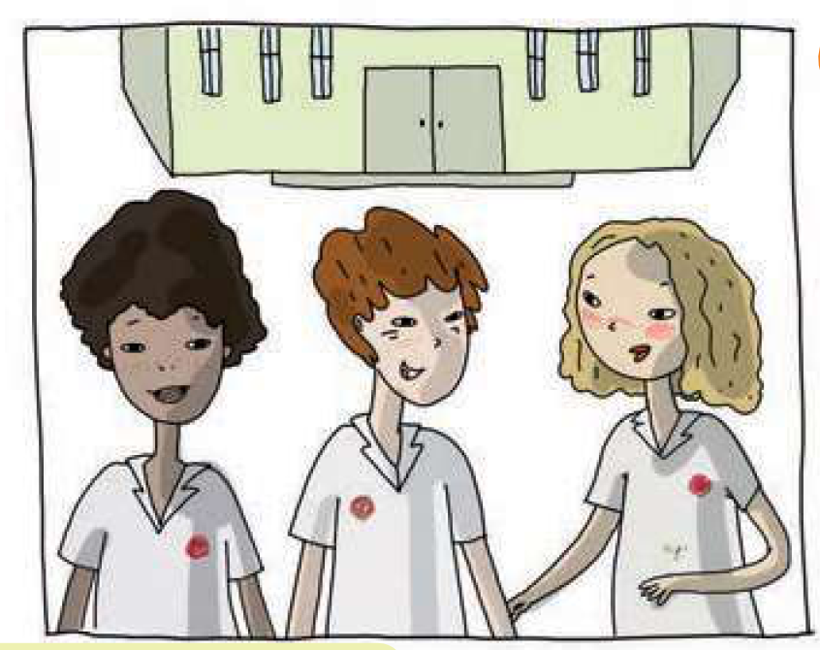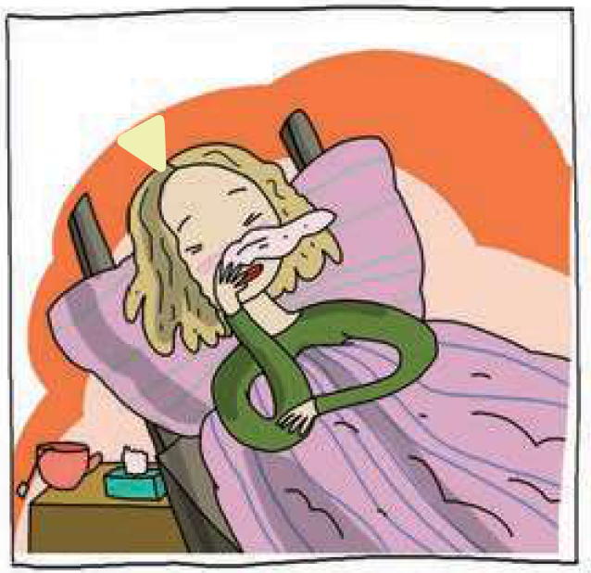
Maya
Emma
Thomas
It was a bad cold.
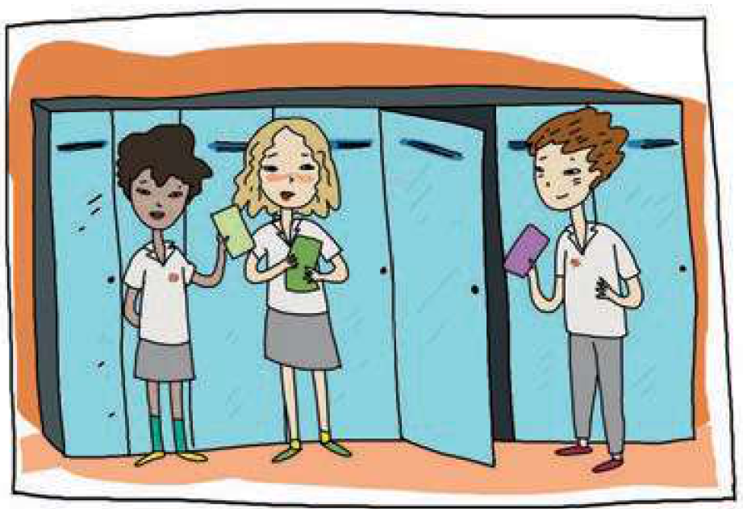
We were at a science museum.
I’m glad you are feeling better.
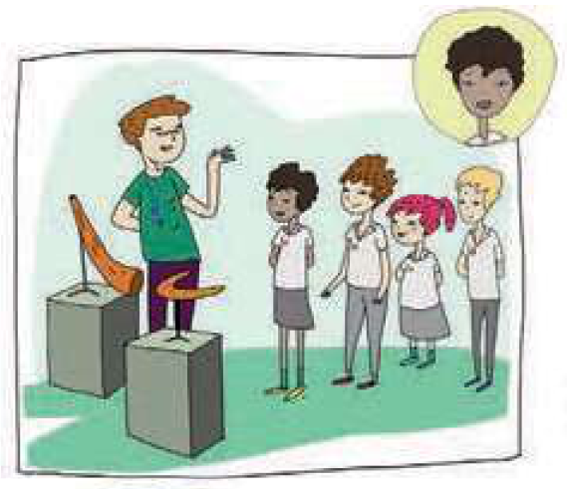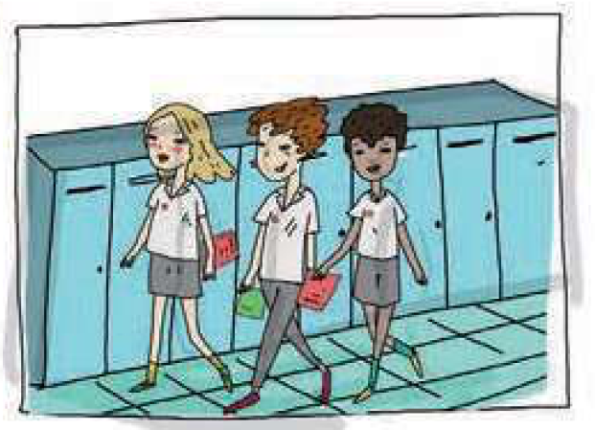
It was interesting.

b) Read the cartoon again. Match the questions to the answers.
Pročitaj strip ponovo. Poveži pitanja i odgovore.
1 Was Maya ill?  Je li Maya bila bolesna? | Yes, she was.
2 Was Maya at school?  Je li Maya bila u školi? | Yes, it was.
3 Was Emma glad Maya was better?  Je li Emmi drago da je Maya bolje? | No, she wasn’t.
4 Were Thomas and his class at a science museum?  1  Jesu li Thomas i njegov razred bili u prirodoslovnom  muzeju? | Yes, she was.
5 Was it interesting?  Je li bilo zanimljivo? | Yes, they were.

c) Choose your role in the dialogue. Do you want to be Maya, Emma or Thomas?
Circle the correct answer. Then act out the cartoon with your friend.
Odaberi svoju ulogu u dijalogu. Želiš li biti Maya, Emma ili Thomas?
Zaokruži točan odgovor. Zatim odglumi strip sa svojim prijateljem / prijateljicom.
1 I want to be Maya because she was ill and she wasn’t at  school.  Želim biti Maya jer je ona bila bolesna i nije bila u školi. | YES | NO
2 I want to be Emma because she was glad Maya was  better.  Želim biti Emma jer joj je bilo drago što je Maja bolje. | YES | NO
3 I want to be Thomas because he and his class were at  a science museum.  Želim biti Thomas jer su on i njegov razred bili u  prirodoslovnom muzeju. | YES | NO

THE PAST SIMPLE OF THE VERB TO BE

My…
GRAMMAR!
PROŠLO VRIJEME GLAGOLA BITI
LOOK AND READ!
Positive sentence | Negative sentence
I was ill.  Ja sam bio / bila bolesna. | I wasn’t (was not) at school.  Ja nisam bio/bila u školi.
You were at school.  Ti si bio / bila u školi. | You weren’t (were not) at home.  Ti nisi bio/bila kod kuće.
Emma (She) was at school, too.  Emma (Ona) je bila u školi također. | She wasn’t at the cinema.  Ona nije bila u kinu.
Thomas (He) was with his friends.  Thomas (On) je bio sa svojim prijateljima. | He wasn’t alone.  On nije bio sam.
It was interesting.  Bilo je zanimljivo. | It wasn’t boring.  Nije bilo dosadno.
We were all happy.  Svi smo bili sretni. | We weren’t sad.  Mi nismo bili tužni.
You were in the park.  Vi ste bili u parku. | You weren’t at school.  Vi niste bili u školi.
They were at a museum.  Oni su bili u muzeju. | They weren’t at the zoo.  Oni nisu bili u zološkom vrtu.
3
a) Translate into Croatian.
Prevedi na hrvatski jezik.
sam bio / bila
1 I was | Ja ____________ | 1 We were | Mi ____________
2 You were | Ti ____________ | 2 You were | Vi ____________
3 He was  She was  It was | On ____________  Ona____________  Ono____________ | 3 They were | Oni ____________
b) Look at the pictures. Where were they last week? Complete the sentences. Then
translate them. Read the sentences to your teacher.
Pogledaj slike. Gdje su bili prošli tjedan? Nadopuni rečenice. Zatim ih prevedi. Pročitaj
rečenice svojoj učiteljici.

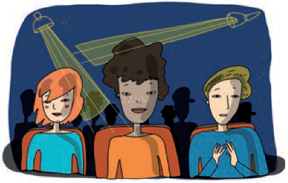  1 | 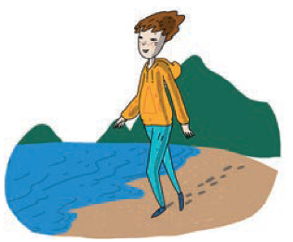  2 | 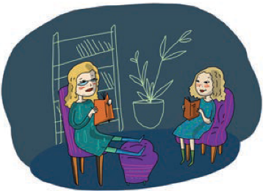  3
at the theatre | on the beach | at home
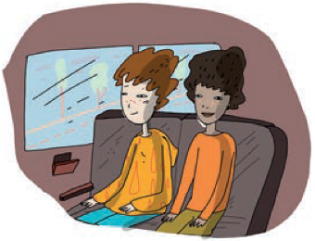  4 | 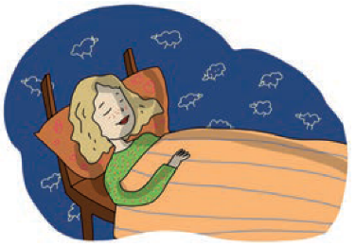  5 | 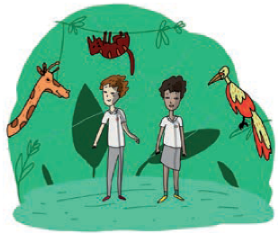  6
on the bus | in the bed | at the zoo
at the theatre.
1 Emma was _________________________________________.
Emma je bila u kazalištu.
____________________________________________________.
2 She was ____________________________________________.
_____________________________________________________.
3 They were ___________________________________________.
_____________________________________________________.
4 They _______________________________________________.
_____________________________________________________.
5 She ________________________________________________.
_____________________________________________________.
6 They _______________________________________________.
_____________________________________________________.

c) Read the sentences and change them into negative.
Pročitaj rečenice i promijeni ih u niječni oblik.

1 Maya was in bed last Sunday.
Maya wasn’t in bed last Sunday.
_______________________________________________________.
2 Maya was at school yesterday.
_______________________________________________________.
3 Thomas was on the beach.
_______________________________________________________.
4 They were on the train.
_______________________________________________________.
5 Children were at the zoo.
_______________________________________________________.
6 We were in Sydney.
_______________________________________________________.

THE PAST SIMPLE OF THE VERB TO BE - QUESTIONS

My…
GRAMMAR!
PROŠLO VRIJEME GLAGOLA BITI - PITANJA
She was at home.  Was she at home? | Yes, she was.  No, she wasn’t.
They were at the zoo.  Were they at the zoo? | Yes, they were.  No, they weren’t.

a) Read where children were last week.
4
Pročitaj gdje su djeca bila prošli tjedan.

Maya was at home in bed. She was ill.
Maya je bila kod kuće u krevetu. Bila je bolesna.
John and his parents were in Sydney.
John i njegovi roditelji su bili u Sydneyu.
He was happy to see his grandparents again.
On je bio sretan što ponovo vidi djeda i baku.
Emma and her mother were at the theatre last Saturday.
Emma i njena mama su bile u kazalištu.
The play was fantastic.
Predstava je bila fantastična.
b) Complete the questions. Use was or were. Circle the correct answer.
Nadopuni pitanja. Upotrijebi was ili were. Zaokruži točan odgovor.
Was
1 __________ Maya at school? | a) Yes, she was.  b) No, she wasn’t.
2 __________ Maya at home in bed? | a) Yes, she was.  b) No, she wasn’t.
3 __________ John and his parents in Sydney? | a) Yes, they were.  b) No, they weren’t.
4 __________ John happy to see his grandparents? | a) Yes, he was.  b) No, he wasn’t.
5 __________ Emma at the theatre last Saturday? | a) Yes, she was.  b) No, she wasn’t.
6 __________ the play fantastic? | a) Yes, it was.  b) No, it wasn’t.

