WHO TOLD THIS STORY?
2A

1
a) Look at the pictures with your friend. Read the words.
Pogledaj slike sa svojim prijateljem / prijateljicom. Pročitaj riječi.

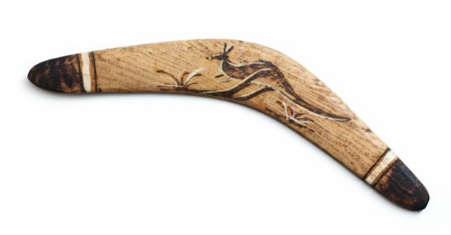
boomerang | ball
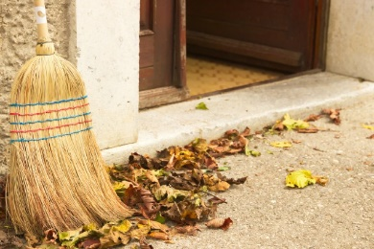 | 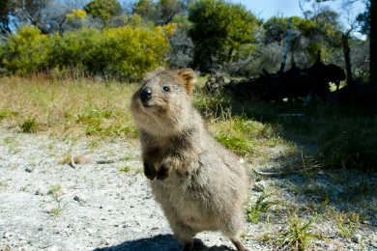
broom | quokka

b) Look at the pictures again. Translate the words into English.
Ponovno pogledaj slike. Prevedi riječi na engleski jezik.

1 metla | ____________________________
2 bumerang | ____________________________
3 kuoka | ____________________________
4 lopta | ____________________________

c) Write the missing letters. Read the words and say what they mean.
Napiši slova koja nedostaju. Pročitaj riječi i kaži što znače.

br __ __ m | b __ __ merang
quo __ __ a | ba __ __
2
a) Who told this story? Read the story and answer the question.
Tko je ispričao ovu priču? Pročitaj priču i odgovori na pitanje.

Yesterday I got up early.
Jučer sam se ustala rano.
I left the cool shade of our tree.
Napustila sam prohladnu sjenu našeg drveta.
I saw a place with human food.
Vidjela sam mjesto s ljudskom hranom.
An angry lady took a broom and chased me away.
Ljutita gospođa je uzela metlu i otjerala me.
Then, I went to the beach.
Zatim sam otišla na plažu.
There I met a human joey.
Tamo sam srela ljusko mladunče.
She took a photo of me.
Ona me je fotografirala.

Who told this story?
Tko je ispričao ovu priču?

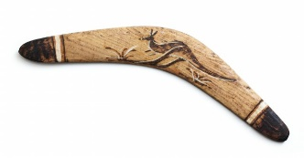 |  | 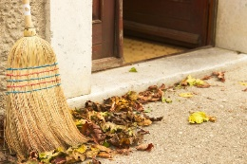 | 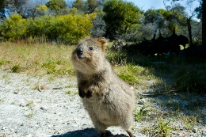
boomerang | ball | broom | quokka

The _____________________ told this story.

b) Read the text again and circle the correct answer.
Pročitaj ponovo tekst i zaokruži točan odgovor.

1 The quokka lives in a tree.  Kuoka živi na stablu. | YES | NO
2 It saw a place with animal food.  Vidjela je mjesto s hranom za životinje. | YES | NO
3 A lady liked the quokka.  Gospođi se svidjela kuoka. | YES | NO
4 The quokka met a nice girl on the beach.  Kuoka je srela dobru djevojčicu na plaži. | YES | NO
5 The girl took a photo of the quokka.  Djevojčica je fotografirala kuoku. | YES | NO

c) Complete the sentences with the words from the box.
Dopuni rečenice s riječima iz kućice.

left saw went took met got

got
1 Yesterday, the quokka ____________up early and ___________ the tree.
Jučer se kuoka ustala rano i napustila stablo.
2 An angry lady ____________ a broom and chased it away.
Ljutita gospođa je uzela metlu i otjerala ju je.
3 The quokka ___________ to the beach and ____________ a girl.
Kuoka je otišla na plažu i srela djevojčicu.
4 The girl __________ the quokka and took a photo of it.
Djevojčica je vidjela kuoku i fotografirala ju je.

a) Who told this story? Read the story and answer the question.
3
Tko je ispričao ovu priču? Pročitaj priču i odgovori na pitanje.

Yesterday I was in a toy box.
Jučer sam bio u kutiji za igračke.
I felt lonely.
Osjećao sam se osamljeno.
I was there with a kangaroo, a ball and a lot of other toys.
Tamo sam bio s klokanom, loptom i mnogo drugih igračaka.
I had no friends.
Nisam imao prijatelja.
Then I saw a human face.
Tada sam vidio ljudsko lice.
A little girl picked me up.
Mala djevojčica me je podigla.
Then, a boy threw me in the air and I flew again!
Dječak me zatim bacio u zrak i ja sam ponovno letio!

Who told this story?
Tko je ispričao ovu priču?

boomerang | ball | broom | kuokka

The _____________________ told this story.

b) Read the text again and circle the correct answer.
Pročitaj ponovo tekst i zaokruži točan odgovor.

1 The boomerang felt lonely.  Bumerang se osjećao usamljeno. | YES | NO
2 It was alone in the toy box.  Bio je sam u kutiji. | YES | NO
3 It had no friends.  Nije imao prijatelja. | YES | NO
4 A little girl picked it up.  Mala djevojčica ga je podignula. | YES | NO
5 A boy played with the boomerang.  Dječak se igrao s bumerangom. | YES | NO

c) Complete the sentences with the words from the box.
Dopuni rečenice riječima iz kućice.

air toy box friends girl happy lonely

toy box
1 The boomerang was in a________________.
Bumerang je bio u kutiji za igračke.
2 It felt _______________ because it had no________________.
Osjećao se usamljeno jer nije imao prijatelja.
3 Then he saw a ____________.
Tada je vidio djevojčicu.
4 A boy threw the boomerang in the ____________.
Dječak je bacio bumerang u zrak.
5 The boomerang was ___________.
Bumerang je bio sretan.
THE PAST SIMPLE – IRREGULAR VERBS

My…
GRAMMAR!
PROŠLO VRIJEME – NEPRAVILNI GLAGOLI
LOOK AND READ!
POGLEDAJ I PROČITAJ!
Present | Past
Regular verbs
Pravilni glagoli
I want a new toy every day.  Ja želim novu igračku svaki dan. | My brother wanted a new toy yesterday.  Moj brat je želio novu igračku jučer.
I play with my friends every day.  Igram se sa svojim prijateljima svaki dan. | I played with my friends two hours ago.  Igrao sam se sa svojim prijateljima prije dva sata.
Pravilnim glagolima u prošlom vremenu dodajemo nastavak –ed.

want – wanted play – played

Irregular verbs
Nepravilni glagoli
I see my friends every day.  Vidim svoje prijatelje svaki dan. | I saw my friends two hours ago.  Vidio sam svoje prijatelje prije dva sata.
I meet my aunt every Sunday.  Susrećem se sa svojom tetom svaku nedjelju. | I met my aunt last Sunday.  Susreo sam svoju tetu prošlu nedjelju.
Nepravilni glagoli imaju poseban oblik u prošlom vremenu.

see – saw meet – met
4
a) Circle the irregular verbs you can find in the quokka’s story. Exercise 2 a) can
help you.
Zaokruži nepravilne glagole koje možeš pronaći u kuokinoj priči. Zadatak 2. a) može ti
pomoći.
1 be (biti) | was/were | 6 go (ići) | went
2 get up (ustati) | got up | 7 have (imati) | had
3 feel (osjećati) | felt | 8 meet (sresti) | met
4 see (vidjeti) | saw | 9 take (uzeti) | took
5 leave (napustiti) | left | 10 throw (baciti) | threw
b) The quokka compares what it usually does and what it did yesterday.
Complete the sentences in the past.
Kuoka uspoređuje što obično radi i što je radila jučer. Dopuni rečenice u prošlosti.
USUALLY - OBIČNO | YESTERDAY - JUČER  got
1 I usually get up late.  Obično se ustajem kasno. | I ____________ up late yesterday.  Jučer sam se ustala kasno.
2 I don’t leave my tree.  Ja ne napuštam svoje drvo. | I ____________ the tree.  Napustila sam drvo.
3 I don’t see many people.  Ne vidim mnogo ljudi. | I ____________ human food.  Vidjela sam ljudsku hranu.
4 They don’t chase me away.  Oni me ne tjeraju. | An angry lady __________me away.  Ljuta gospođa me otjerala.
5 I don’t go to the beach.  Ne idem na plažu. | I ___________ to the beach.  Otišla sam na plažu.
6 I don’t meet any children.  Ne srećem djecu. | I ___________ a girl.  Srela sam djevojčicu.
7 They don’t take a photo of me.  Ne fotografiraju me. | She ___________ a photo of me.  Ona me je fotografirala.
5
a) Copy the past simple forms of the verbs in the box next to the correct verb base
form. Read and translate.
Prepiši past simple oblik glagola u kućici pokraj točnog glagola u infinitivu. Pročitaj i
prevedi.
jumped took worked went met talked saw learned

regular verbs  jumped ped |  | irregular verbs  went ped
jump | ______________ | go | ______________
talk | ______________ | meet | ______________
learn | ______________ | take | ______________
work | ______________ | see | ______________
b) Underline the verb in each sentence. Then rewrite the sentences in
the past simple.
Podcrtaj glagol u svakoj rečenici. Zatim ponovo napiši rečenice u prošlom vremenu
(past simple).

1 I meet my friends every day.
I met my friends
___________________________________ yesterday.
2 They usually work at home.
___________________________________ last year.
3 Maya and Thomas sometimes see quokkas.
___________________________________ two days ago.
4 We go to the zoo every Sunday.
___________________________________ last Sunday.
5 We learn about Australia at school.
____________________________________last month.
6 Maya sometimes takes photos of her friends.
___________________________________ yesterday.

