CAJUN AND CREOLE
2A
1
a) Read the words with your teacher.
Pročitaj riječi sa svojom učiteljicom.
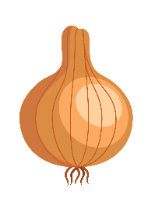
onion | celery | bell pepper
tomato | rice | sausage
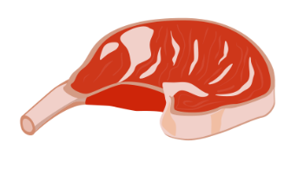 |  | 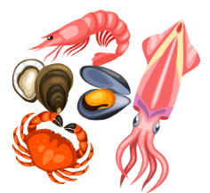
meat | fish | seafood

b) Translate the words into English.
Prevedi riječi na engleski jezik.
1 riža | _______________________________________
2 luk | _______________________________________
3 paprika babura | _______________________________________
4 riba | _______________________________________
5 meso | _______________________________________
6 kobasica | _______________________________________
7 rajčica | _______________________________________
8 plodovi mora | _______________________________________
9 celer | _______________________________________

c) Which food do you often / sometimes / rarely / never eat?
Koju hranu često / ponekad / rijetko / nikad ne jedeš?
1 I often eat _________________________________________________.
2 I sometimes eat ____________________________________________.
3 I rarely ___________________________________________________.
4 I never ___________________________________________________.

d) Translate the sentences from Exercise 1 c) in Croatian.
Prevedi na hrvatski jezik rečenice iz zadatka 1. c).
1__________________________________________________________
2__________________________________________________________
3__________________________________________________________
4__________________________________________________________
2
a) Match the words in English with the words in Croatian.
Poveži riječi na engleskom jeziku s riječima na hrvatskom jeziku.
1 spices | jelo
2 fresh  1 | sastojci
3 dish | začini
4 ingredients | svježe

b) Translate into English.
Prevedi na engleski jezik.
1 svježe povrće __________________
2 dodati začine __________________
3 lokalno jelo __________________
4 ukusni sastojci __________________
a) Holden is talking to his parents about the Creole and Cajun cuisine.
Here’s what he has learned. Read the text.
3
Holden razgovara sa svojim roditeljima o Creole i Cajun kuhinji. Evo što je naučio.
Pročitaj tekst.

Food is one of the most important parts of the Mardi Gras party.
Hrana je jedan od najvažnijih dijelova pokladne proslave.
In Lousiana, food is very important because it connects people.
U Lousiani je hrana vrlo važna jer povezuje ljude.
It keeps the tradition alive.
Ona čuva tradiciju živom.
Holden’s mom likes Creole cuisine.
Holdenova mama voli Creole kuhinju.
Creole cuisine is city food in New Orleans.
Creole kuhinja je urbana (gradska) hrana u New Orleansu.
Creole ingredients are spices, fresh vegetables, fish and meat.
Creole sastojci su začini, svježe povrće, riba i meso.
Holden’s dad prefers Cajun cuisine.
Holdenov tata više voli Cajun kuhinju.
Cajun cuisine is country food in Louisiana.
Cajun kuhinja je seoska hrana u Lousiani.
The most important vegetables in Cajun dishes are onion, celery and bell pepper.
Najvažnije povrće u Cajun jelima su luk, celer i paprika babura.
Gumbo is a specialty of both cuisines, Creole and Cajun.
Gumbo je specijalitet obje kuhinje, Creole i Cajun.

b) Read the text again. Are the sentences correct? Circle True or False.
Pročitaj ponovo tekst. Jesu li rečenice točne? Zaokruži točno (True) ili netočno (False).
1 Food is important in Lousiana.  Hrana je važna u Lousiani. | True | False
2 Food is very important because it is cheap.  Hrana je jako važna jer je jeftina. | True | False
3 Holden’s mom likes Creole cuisine.  Holdenova mama voli Creole kuhinju. | True | False
4 Creole cuisine is country food in New Orleans.  Creole kuhinja je seoska hrana u Louisiani. | True | False
5 Holden’s dad prefers Cajun cuisine.  Holdenov tata više voli Cajun kuhinju. | True | False
6 Gumbo is a Chinese specialty.  Gumbo je kineski specijalitet. | True | False

c) Complete the sentences. Exercise 3 a) can help you.
Dopuni rečenice. Zadatak 3. a) može ti pomoći.

1 Creole cuisine is _______________ food in New Orleans.
Creole kuhinja je gradska hrana u New Orleansu.
2 Creole _______________ are spices, fresh vegetables, fish and meat.
Creole sastojci su začini, svježe povrće, riba i meso.
3 Holden’s dad _______________ Cajun cuisine.
Holdenov tata više voli Cajun kuhinju.
4 Cajun cuisine uses _____________, _____________ and ______________.
Cajun kuhinja koristi luk, celer i papriku.

a) Gumbo is not the same in Creole and Cajun cuisine. Read the text and write
the ingredients for each cuisine.
4
Gumbo nije isti u Creole i Cajun kuhinji. Pročitaj tekst i napiši sastojke za svaku
kuhinju.

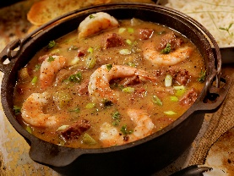
In Creole cuisine gumbo is made with vegetables, seafood,
sausage and a lot of tomatoes.
U Creolskoj kuhinji gumbo se radi s plodovima mora,
kobasicom i mnogo rajčice.
In Cajun cuisine it is made with vegetables, seafood, chicken, sausage
and no tomatoes.
U Cajunskoj kuhinji radi se s plodovima mora, piletinom, kobasicom i
bez rajčice.
It is served with cooked rice in both cuisines.
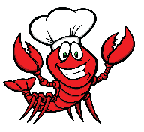
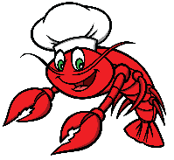
Poslužuje se s kuhanom rižom u obje kuhinje.

Creole cuisine | Cajun cuisine
_____________________________  _____________________________  _____________________________  _____________________________  _____________________________ | _____________________________  _____________________________  _____________________________  _____________________________  _____________________________
b) Answer the questions about yourself.
Odgovori na pitanja o sebi.
What is your favourite local food?
_____________________________________________________________
What ingredients do you need to make it?
_____________________________________________________________
_____________________________________________________________
COUNTABLE AND UNCOUNTABLE NOUNS

My…
GRAMMAR!
BROJIVE I NEBROJIVE IMENICE

LOOK AND READ!
Brojive imenice su one koje možemo prebrojati. Mogu biti u jednini i množini.
an apple a carrot a pepper | three apples two carrots four peppers
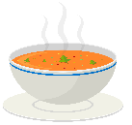
Nebrojive imenice ne možemo brojati. Imenice imaju samo oblik jednine.

soup salt water butter rice
juha sol voda maslac riža

Količinu nebrojivih imenica možemo izraziti na različite načine.
a bowl of soup two kilos of salt three glasses of water
zdjela juhe dva kilograma soli tri čaše vode
5
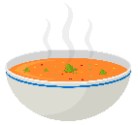
Prouči primjere, razmisli i odgovori. Što brojimo u sljedećim primjerima?
a) zdjele b) juhu
two bowls of soup
dvije zdjele juhe
a) čaše b) vodu
three glasses of water
tri čaše vode
Brojive imenice su ____________________ i ______________________.
Nebrojive imenice su _________________ i _______________________.
a) Circle the countable nouns red and uncountable nouns blue.Copy them under
the right heading.
6
Zaokruži brojive imenice crvenom bojom i nebrojive imenice plavom bojom. Prepiši ih
ispod odgovarajućeg naslova.
coffee  kava | city  grad | milk  mlijeko | egg  jaje | soup  juha
tomato  rajčica | banana  banana | honey  med | water  voda | orange  naranča

COUNTABLE NOUNS  brojive imenice | UNCOUNTABLE NOUNS  nebrojive imenice

b) Write and draw two countable and two uncountable nouns.
Napiši i nacrtaj dvije brojive i dvije nebrojive imenice.

Countable nouns Uncountable nouns

