2A
HEALTH AND TECH
1
a) Match.
Poveži.
1 technology | glavobolja
2 wrist  1 | tehnologija
3 headache | osjećati bol
4 to prescribe a medicine | ergonomski udobna sjedalica
5 to be in pain | provoditi vrijeme na internetu
6 to feel pain | prepisati lijek
7 ergonomic chair | zglob na ruci
8 to spend time online | biti u bolovima

b) Translate the words into Croatian.
Prevedi riječi na hrvatski jezik.
1 glavobolja ___________________________________________
2 tehnologija ___________________________________________
3 osjećati bol ___________________________________________
4 prepisati lijek ___________________________________________
5 zglob na ruci ___________________________________________
6 biti u bolovima ___________________________________________
7 ergonomski udobna stolica _________________________________
8 provoditi vrijeme na internetu _______________________________

a) Match the words. Exercise 1 a) can help you.
2
Poveži riječi. Zadatak 1. a) može ti pomoći.

1 to feel | chair
2 to spend | in pain
3 to prescribe | time online
4 ergonomic  1 | pain
5 to be | medicine

b) Copy the expressions from Exercise 2 a). Then translate them into Croatian.
Prepiši izraze iz zadatka 2. a). Zatim ih prevedi na hrvatski jezik.
osjećati bol
to feel pain
________________________________ _______________________________
________________________________ _______________________________
________________________________ _______________________________
________________________________ _______________________________
________________________________ _______________________________

c) Fill in the missing letters. Read them to your teacher.
Dopuni slova koja nedostaju. Pročitaj ih učiteljici.
1 f __ __ l pa __ n  2 wr __ s __  3 tec __ nolog __ | 4 he __ dac __ e  5 m __ dic __ ne  6 pr __ scri __ e

a) Read the text.
3
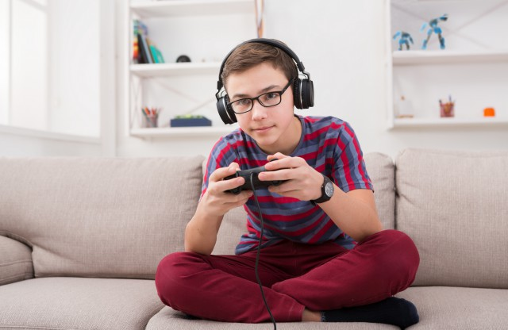
Pročitaj tekst.
Connor's hobby is gaming.
Connorov hobi je igranje igara.
He has spent too much time online.
On je proveo previše vremena na internetu.
He has felt pain in his wrist and had a headache.
Osjetio je bol u zglobu na ruci i imao glavobolju.
He has been in pain for a week.
Boli ga već tjedan dana.
He has never felt these symptoms before.
Nikad prije nije imao ovakve simptome.
The doctor has prescribed him some medicine.
Doktor mu je prepisao lijek.
He has given Connor a bandage for his wrist.
Dao mu je zavoj za zglob na ruci.
His parents have suggested getting a new, ergonomic chair.
Njegovi roditelji su predložili da nabave novu, ergonomsku stolicu.
Connor should spend more time outdoors and exercise.
Connor bi trebao provoditi više vremena vani i vježbati.
He can go swimming with Molly at the pool.
Može plivati s Molly na bazenu.

b) Are the sentences correct? Circle True or False.
Jesu li rečenice točne? Zaokruži True (točno) ili False (netočno).

1 Connor hasnʼt spent too much time online.  Connor nije proveo previše vremena na internetu. | True | False
2 He has been in pain for two weeks.  Boli ga već dva tjedna. | True | False
3 He has visited the doctor.  Posjetio je doktora. | True | False
4 The doctor has given him a new chair.  Doktor mu je dao novu sjedalicu. | True | False
5 Connor should exercise more.  Connor bi trebao više vježbati. | True | False

c) Circle the correct answer. Read the questions and answers to your teacher.
Zaokruži točan odgovor. Pročitaj pitanja i odgovore učiteljici.

1 Has Connor been in pain? | a) Yes, he has. | b) No, he hasn’t.
2 Has he felt these symptoms before? | a) Yes, he has. | b) No, he hasn’t.
3 Has he felt pain in his neck? | a) Yes, he has. | b) No, he hasn’t.
4 Has the doctor given him a bandage? | a) Yes, he has. | b) No, he hasn’t.
PRESENT PERFECT SIMPLE – questions
My…
GRAMMAR!

PRESENT PERFECT – pitanja

LOOK AND READ!
POGLEDAJ I PROČITAJ!
Upitni oblik tvorimo zamjenom mjesta subjekta i glagola have.
He has felt pain in his wrist.  Has he felt pain in his wrist? | They have visited doctor.  Have they visited doctor?

Make questions about Connor.
Postavi pitanja o Connoru.
4
He has felt pain. On je osjetio bol.
Has he felt pain? Je li on osjetio bol?

1 He has played many games. _______ he played many games?
Odigrao je mnogo igara.
2 He has listened to his doctor. _______ he ____________ to his doctor?
Poslušao je doktora.
3 They have gone shopping. _______ they ____________ shopping?
Otišli su u kupovinu.

4 They have bought a new chair. _______ they ____________ a new chair?
Kupili su novu stolicu.
PRESENT PERFECT SIMPLE – short answers
My…
GRAMMAR!

PRESENT PERFECT – kratki odgovori

LOOK AND READ!
POGLEDAJ I PROČITAJ!
Has he felt pain in his wrist? Yes, he has.
No, he hasn't.

Have they visited doctor? Yes, they have.

No, they haven't.

5
5 Answer the questions. Use short answers.
Odgovori na pitanja. Upotrijebi kratke odgovore.

1 Has Connor spent too much time online? Yes, he ____________.
2 Has he got a bandage? Yes, he ____________.
3 Has he visited his granny? No, he _____________.
4 Has he been in hospital? No, he _____________.
5 Have they bought a new chair? Yes, they ___________.
6 Have they gone swimming? No, they _____________.

6
a) Circle the answer that is true for you.
Zaokruži odgovor koji je istinit za tebe.

1 Have you taken a pill for your headache?  Jesi li uzeo / uzela tabletu za glavu? | a) Yes, I have.  b) No, I haven’t.
2 Have you ever played games for 4 hours?  Jesi li ikada igrao / igrala igrice četiri sata? | a) Yes, I have.  b) No, I haven’t.
3 Have you ever played games all day?  Jesi li ikada igrao / igrala igrice cijeli dan? | a) Yes, I have.  b) No, I haven’t.
4 Have you ever spent all night on a computer?  Jesi li ikada proveo / provela cijelu noć za  računalom? | a) Yes, I have.  b) No, I haven’t.
5 Have you ever had shoulder pain?  Jesi li ikada osjećao / osjećala bol u ramenima? | a) Yes, I have.  b) No, I haven’t.
6 Have you ever skipped meals because of gaming?  Jesi li ikada preskočio / preskočila jelo zbog  igranja igrica? | a) Yes, I have.  b) No, I haven’t.

b) Write a report. Circle the correct words. Read them to your teacher.
Napiši izvješće. Zaokruži točne riječi. Pročitaj ih učiteljici.

1 I have / haven’t taken a pill for a headache.

2 I have / haven’t played games for 4 hours.

3 I have / haven’t played games all day.

4 I have / haven’t spent all night on a computer.

5 I have / haven’t had shoulder pain.

6 I have / haven’t skipped meals because of gaming.

c) Translate the sentences from Exercise 6 b) into Croatian.
Prevedi rečenice iz zadatka 6. b) na hrvatski jezik.

1 ________________________________________________________
2 ________________________________________________________
3 ________________________________________________________
4 ________________________________________________________
5 ________________________________________________________
6 ________________________________________________________

