



1

**a)** **Match the words in English with the words in Croatian.**

Poveži riječi na engleskom jeziku s riječima na hrvatskom jeziku.

|  |  |
| --- | --- |
| 1 move | posao |
| 2 job | glavni grad  1 |
| 3 native people | preseliti se |
| 4 island | znakovni jezik |
| 5 whale | domoroci |
| 6 capital (city) | jezero |
| 7 lake | otok |
| 8 sign language | kit |

**b)** **Translate the words into English.**

Prevedi riječi na engleski jezik.

job

|  |  |
| --- | --- |
| 1 posao | ________________________________ |
| 2 jezero | ________________________________ |
| 3 znakovni jezik | ________________________________ |
| 4 glavni grad | ________________________________ |
| 5 otok | ________________________________ |
| 6 domoroci | ________________________________ |
| 7 kit | ________________________________ |
| 8 preseliti se | ________________________________ |

**c)** **Write what you can see in the pictures. Words from Exercise 1 a) can help   
 you.**

Napiši što vidiš na slikama. Riječi iz zadatka 1. a) mogu ti pomoći.

|  |  |
| --- | --- |
| native people  1 __________________ | 2 __________________ |
| 3 __________________ | 4 __________________ |
| 5 __________________ | 6 __________________ |

**a) Read the text about Manaia to your teacher or your friend.**

2

Pročitaj tekst o djevojčici Manaiji učiteljici ili prijatelju / prijateljici.

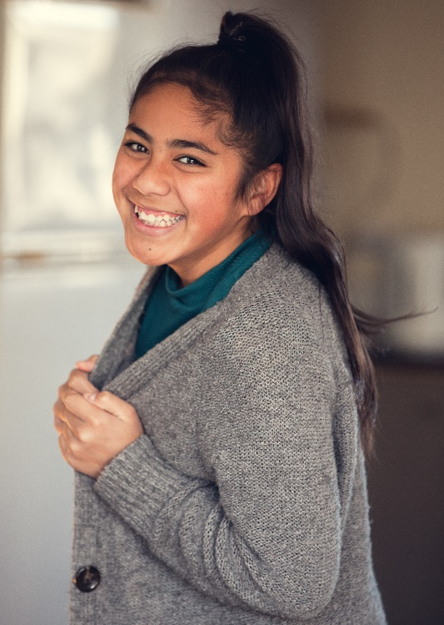Hi! My name is Manaia.

Bok! Moje ime je Manaia.

I am twelve years old.

Imam dvanaest godina.

I am from Ireland.

Ja sam iz Irske.

Last year my family moved to New Zealand.

Prošle se godine moja obitelj preselila na Novi Zeland.

My dad got a new job there.

Moj tata je tamo dobio novi posao.

My grandparents live in Wellington, the capital of New Zealand.

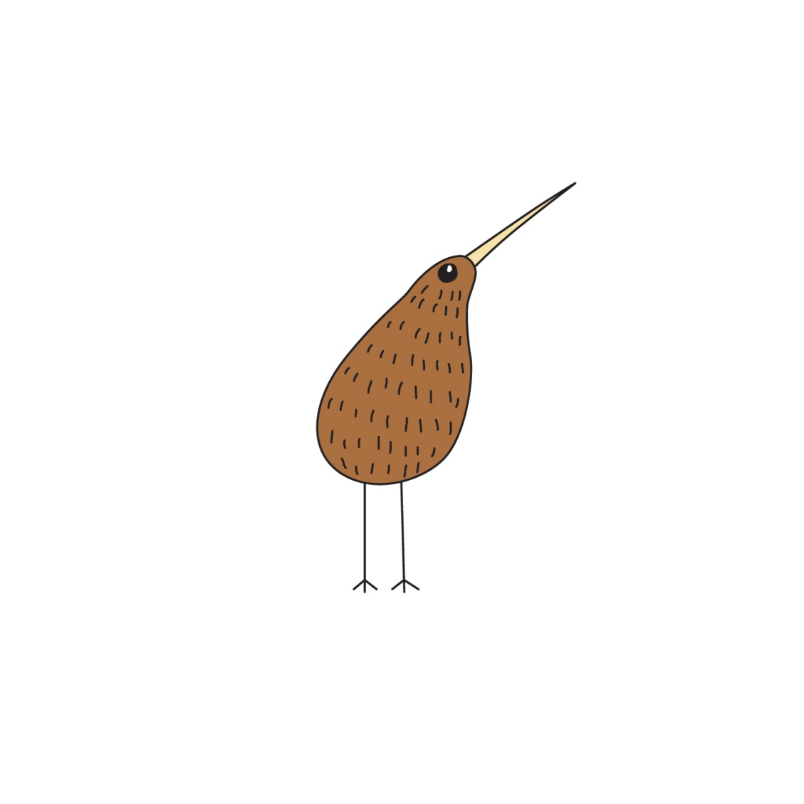Moji djed i baka žive u Wellingtonu, glavnome gradu Novog Zelanda.

They are Māori.

Oni su Maori.

Māori are the native people of New Zealand.

Maori su domoroci na Novom Zelandu.

People from New Zealand are called Kiwis.

Ljudi s Novog Zelanda se zovu Kiviji.

**b) Are the sentences correct? Circle True or False.**

Jesu li rečenice točne? Zaokruži True (točno) ili False (netočno).

|  |  |  |
| --- | --- | --- |
| 1 Manaia is from Scotland.  Manaia je iz Škotske. | True | False |
| 2 Manaia moved to New Zealand.  Manaia se preselila na Novi Zeland. | True | False |
| 3 Manaia is twelve.  Manaia ima dvanaest godina. | True | False |
| 4 People from Ireland are called Kiwis.  Ljudi iz Irske se zovu Kiviji. | True | False |
| 5 Manaiaʼs grandparents live in Auckland.  Manaijini djed i baka žive u Aucklandu. | True | False |
| 6 Manaiaʼs father got a new job in New Zealand.  Manaijin otac je dobio novi posao na Novom Zelandu. | True | False |

**c) Answer the questions.**

Odgovori na pitanja.

1 Where is Manaia from?

Odakle je Manaia?

Manaia is from ____________________________________________.

2 How old is Manaia?

Koliko godina ima Manaia?

Manaia is ________________________________________________.

3 Where did Manaiaʼs family move?

Gdje se Manaijina obitelj preselila?

Manaiaʼs family moved ______________________________________.

4 Where do Manaiaʼs grandparents live?

Gdje Manaijini djed i baka žive?

_________________________________________________________.

**a) Read the text about New Zealand.**

3

Pročitaj tekst o Novom Zelandu.

New Zealand consists of two big islands and 600 smaller ones.

Novi Zeland se sastoji od dva velika otoka i 600 otočića.

The big islands are called the North Island and the South Island.

Veliki se otoci zovu Sjeverni i Južni otok.

Wellington is the capital city of New Zealand.

Wellington je glavni grad Novog Zelanda.

Wellington is situated in the south of the North Island.

Wellington se nalazi na južnom dijelu Sjevernoga otoka.

Auckland is the biggest city in New Zealand.

Auckland je najveći grad na Novom Zelandu.

Auckland is situated in the north of the North Island.

Auckland se nalazi na sjevernom dijelu Sjevernog otoka.

There are many interesting places in New Zealand.

Ima mnogo zanimljivih mjesta na Novom Zelandu.

You can watch whales in Kaikoura, on the South Island.

Možeš gledati kitove u Kaikouri, na Južnome otoku.

Rotorua is famous for its lakes.

Rotorua je poznata po svojim jezerima.

New Zealand has three official languages: English, Māori and sign language.

Novi Zeland ima tri službena jezika: engleski, maorski i znakovni jezik.

**b)** **Look at the map. Label it with the words from the box. Exercise 3 a) can help   
 you.**

Pogledaj kartu. Označi je riječima iz kućice. Zadatak 3. a) može ti pomoći.

Auckland Island Kaikoura South Wellington

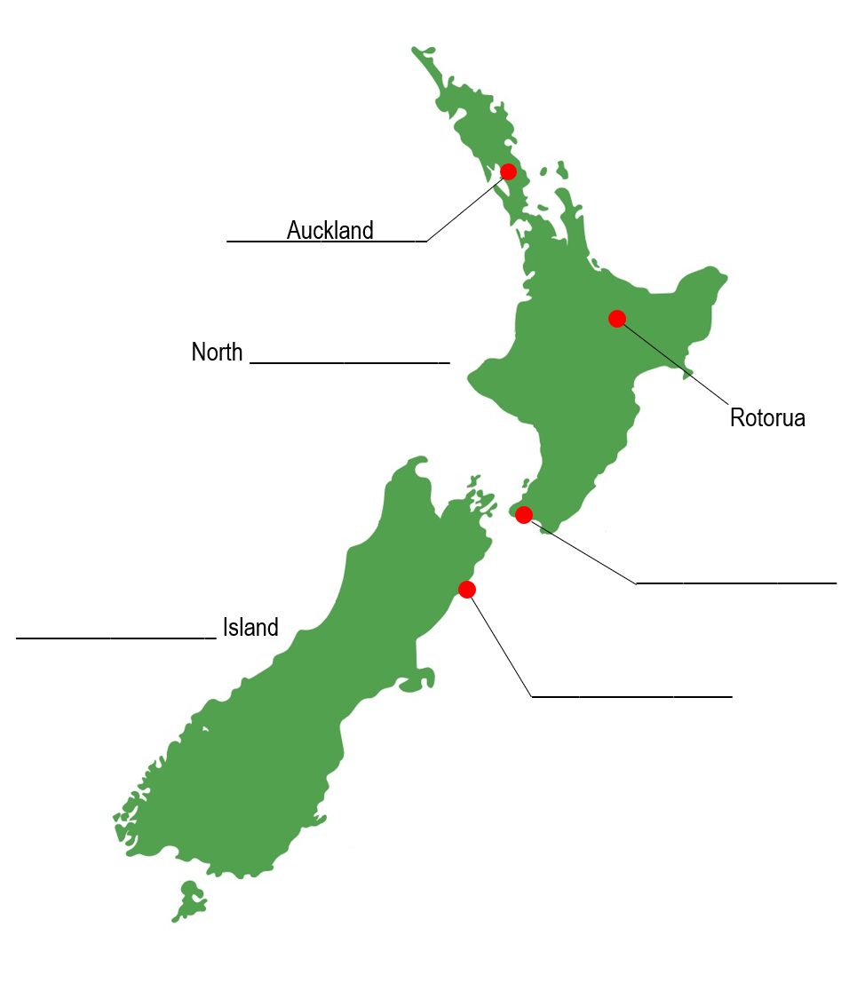



4

**a)** **Match and colour.**

Poveži i oboji.

the biggest city

1

Māori

the name for people from New Zealand

v

2

Wellington

a city on the South Island

3

Kiwi

native people of New Zealand

4

Auckland

the capital city

5

Kaikoura

**b) Complete the sentences with the words from the box.**

Dopuni rečenice riječima iz kućice.

biggest islands sign capital moved

moved

1 Manaiaʼs family _________________ to New Zealand.

Manaijina obitelj **se preselila** na Novi Zeland.

2 Auckland is the _________________ city in New Zealand.

Auckland je **najveći** grad na Novom Zelandu.

3 Wellington is the _________________ city of New Zealand.

Wellington je **glavni** grad Novog Zelanda.

4 _________________ language is an official language in New Zealand.

**Znakovni** jezik je službeni jezik na Novom Zelandu.

5 New Zealand consists of two big _________________.

Novi Zeland se sastoji od dva velika **otoka**.