1B
OBSTACLES AND SUCCESS
1
a) Look at the pictures and read the words.
Pogledaj slike i pročitaj riječi.

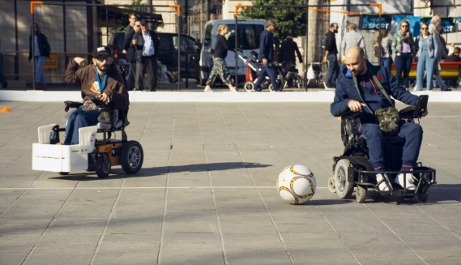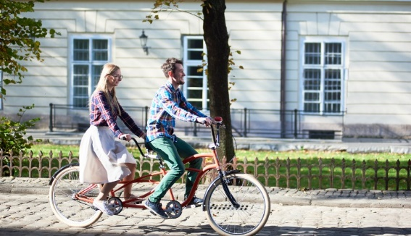
powerchair football tandem cycling

b) Translate the words into English.
Prevedi riječi na engleski jezik.
1 nogomet u invalidskim kolicima | _______________________________
2 biciklizam u dvoje | _______________________________
2
a) Match the words in English with the words in Croatian.
Spoji riječi na engleskom jeziku s riječima na hrvatskom jeziku.

1 wheelchair | propustiti
2 miss | bicikl za dvoje
3 competition | slabovidan
4 visually impaired  1 | invalidska kolica
5 blind | slijep
6 tandem bike | natjecanje
b) Translate the words into English.
Prevedi riječi na engleski jezik.

1 slijep | _______________________________________________
2 slabovidan | _______________________________________________
3 propustiti | _______________________________________________
4 natjecanje | _______________________________________________
5 bicikl za dvoje | _______________________________________________
6 invalidska kolica | _______________________________________________
3
a) Read the text to your teacher.
Pročitaj tekst učiteljici.

Fiona can't walk. She uses her wheelchair to move around.
Fiona ne može hodati. Ona koristi invalidska kolica za kretanje.

She is interested in sports and she is active in her club.
Nju zanima sport i ona je aktivna u svom klubu.

She plays powerchair football.
Ona igra nogomet u invalidskim kolicima.

She hasn't missed one game this year.
Nije propustila niti jednu igru ove godine.

Her club has been invited to an international competition.
Njen klub je pozvan na međunarodno natjecanje.

Good luck, Fiona!
Sretno, Fiona!

Orla is a visually impaired person.
Orla je slabovidna osoba.

She likes riding the bike with her friend Roisin.
Ona voli voziti bicikl sa svojom prijateljicom Roisin.

They have bought a tandem bike.
One su kupile bicikl za dvoje.

Roisin is the pilot in the team.
Roisin je vodič u timu.

They enjoy the ride in the fresh air.
One uživaju u vožnji na svježem zraku.

Tandem cycling for the blind and visually impaired is popular in Northern Ireland.
Biciklizam u dvoje za slijepe i slabovidne je popularno u Sjevernoj Irskoj.

b) Choose the correct answer. Circle Fiona or Orla.
Odaberi točan odgovor. Zaokruži Fiona ili Orla.
Fiona
Orla
1 Who uses a wheelchair?  Tko koristi invalidska kolica za kretanje? |  | Fiona  Orla
2 Who is a visually impaired person?  Tko je slabovidna osoba? |  | Fiona  Orla
3 Who enjoys the ride in the fresh air?
Tko uživa u vožnji na svježem zraku?

4 Who is active in her club?  Tko je aktivan u svom klubu? |  | Fiona  Orla  Fiona  Orla
5 Who has bought a tandem bike?
Tko je kupio bicikl za dvoje?

6 Who hasn't missed a game this year?  Tko nije propustio niti jednu igru ove godine? |  | Fiona  Orla
c) Answer the questions.
Odgovori na pitanja.

1 What does Fiona play?
Što Fiona igra?
Fiona plays____________________________________________.

2 What does Orla like?
Što Orla voli?
Orla likes_____________________________________________.

3 What has Orla bought?
Što je Orla kupila?
Orla has bought a ______________________________________.

a) Match the pictures with the words.
4
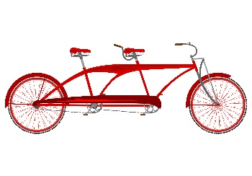
Poveži slike i riječi.

1 four-wheel powerchair
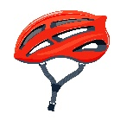
2 a ball
3 helmet
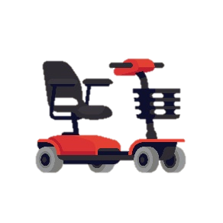
4 gloves

5 a tandem bike

b) Translate the words into English.
Prevedi riječi na engleski jezik.

1 rukavice | ________________________________________________
2 lopta | ________________________________________________
3 kaciga | ________________________________________________
4 bicikl za dvoje | ________________________________________________
5 sportska kolica na  četiri kotača | ________________________________________________

c) Complete the sentences with the words from Exercise 4 b).
Dopuni rečenice s riječima iz zadatka 4. b).

1 For tandem cycling you need __________________________________
__________________________________________________________.
Za vožnju bicikla s dva vozača trebaš…
2 For powerchair football you need _______________________________
__________________________________________________________.
Za nogomet u invalidskim kolicima trebaš…

PRESENT PERFECT SIMPLE – negative form
My…
My…
GRAMMAR!

PRESENT PERFECT – niječni oblik

LOOK AND READ!
POGLEDAJ I PROČITAJ!
Niječni oblik glagolskog vremena present perfect tvorimo niječnim oblikom glagola have (haven’t / hasn’t) i participom prošlim.
POTVRDNI OBLIK | NIJEČNI OBLIK
has played  have played | hasn’t played  haven’t played
I have tried cycling.  Ja sam pokušao voziti bicikl.  He has bought a helmet.  On je kupio kacigu. | I haven’t tried tandem cycling.  Ja nisam pokušao voziti bicikl u dvoje.  He hasn’t bought gloves.  On nije kupio rukavice.
5
a) Write the sentence in negative form. Read them to your teacher.
Napiši rečenice u niječnom obliku. Pročitaj ih svojoj učiteljici.
I haven’t been there.
1 I have been there. __________________________________________.
Bio sam tamo.
2 You have gone home. _______________________________________.
Otišao si kući.
3 She has seen an aquarium. __________________________________.
Ona je vidjela akvarij.
4 He has written a letter. _____________________________________.
On je napisao pismo.
5 We have bought a boat. ____________________________________.
Kupili smo brod.
6 Mary has made a beanie. ___________________________________.
Mary je napravila kapu.

b) Circle the correct answer: a) or b).
Zaokruži točan odgovor: a) ili b).

1 Orla nije vozila bicikl sama.
a) Orla has gone cycling alone.
b) Orla hasn’t gone cycling alone.
2 Pozvala je sestru da joj se pridruži.
a) She has invited her sister to join in.
b) She hasn’t invited her sister to join in.
3 Orla i Roisin nisu igrale odbojku zajedno.
a) Orla and Roisin have played volleyball together.
b) Orla and Roisin haven’t played volleyball together.
4 One su uživale u vožnji na svježem zraku.
a) They have enjoyed the ride in the fresh air.
b) They haven’t enjoyed the ride in the fresh air.

b) Complete the sentences with have, haven’t, has or hasn’t.
Dopuni rečenice sa have, haven’t, has ili hasn’t.

1 Fiona ____________ played an important match.
Fiona je igrala važnu utakmicu.
2 She ____________ missed a single ball.
Nije promašila niti jednu loptu.
3 Her friends ____________ cheered for her.
Njeni prijatelji su navijali za nju.
4 They ____________ seen better game this year.
Nisu vidjeli bolju igru ove godine.
ALREADY and YET
My…
My…
GRAMMAR!

LOOK AND READ!
POGLEDAJ I PROČITAJ!
Glagolsko vrijeme present perfect koristimo s prilozima ALREADY i YET.

Prouči primjere:
I have already won a silver medal.
Ja sam već osvojio srebrnu medalju.
I haven’t won a golden medal yet.
Ja još nisam osvojio zlatnu medalju.

ALREADY (VEĆ) koristimo u potvrdnim rečenicama kada želimo reći da smo nešto već uradili.
YET (JOŠ) koristimo u niječnim rečenicama kada želimo reći da nešto još nismo uradili.

6
Complete the sentences with already or yet.
Dopuni rečenice s already ili yet.

1 I have _______________ tried many sports.
Ja sam već probao mnoge sportove.
2 I haven’t tried boxing _______________.
Još nisam probao boks.
3 My friend has ________________bought everything we need for our trip.
Moja prijateljica je već kupila sve što trebamo za izlet.
4 She hasn’t made sandwiches _______________.
Ona još nije napravila sendviče.
a) Circle the sentences that are true for you.
7
Zaokruži rečenice koje su točne za tebe.

1 a) I have already had a shower this morning.
Ja sam se jutros već otuširao / otuširala.

b) I haven’t had a shower yet.
Ja se još nisam otuširao / otuširala.

2 a) I have already had my breakfast.
Ja sam već doručkovao / doručkovala.

b) I haven’t had my breakfast yet.
Ja još nisam doručkovao / doručkovala.

3 a) I have already been to school today.
Ja sam danas već bio / bila u školi.

b) I haven’t been to school today yet.
Ja danas još nisam bio / bila u školi.

4 a) I have already done my homework.
Ja sam već napisao / napisala zadaću.

b) I haven’t done my homework yet.
Ja još nisam napisao / napisala zadaću.

b) Copy the circled answers on the lines. Report to your teacher.
Prepiši zaokružene odgovore na crte. Reci to učiteljici.

1 ___________________________________________________________
2 ___________________________________________________________
3 ___________________________________________________________
4 ___________________________________________________________
10

