2C
THE NORTH COAST
a) Read the text.
1
Pročitaj tekst.
Molly regularly posts on her blog.
Molly redovito objavljuje članke na svom blogu.
She has visited Londonderry with her parents.
Ona je posjetila Londonderry sa svojim roditeljima.
Read some of her entries.
Pročitaj neke od njenih objava.
2
Match the words in English with the words in Croatian. Then copy them on the
lines.
Poveži riječi na engleskom jeziku s riječima na hrvatskom jeziku. Zatim ih prepiši na
crte.
1 owner | uže, konop
2 to cross | kopno
3 to step | ljuljati se
4 haunted | zakoračiti
5 mainland  1 | uklet
6 to swing | vlasnik
7 rope | prijeći
1_______________________________ ________________________________
2_______________________________ ________________________________
3_______________________________ ________________________________
4_______________________________ ________________________________
5_______________________________ ________________________________
6_______________________________ ________________________________
7_______________________________ ________________________________
a) Read the sentences.
3
Pročitaj rečenice.

We have been on a weekend in Londonderry.
Za vikend smo bili u Londonderryju.
Londonderry is the second-largest city in Northern Ireland.
Londonderry je drugi najveći grad u Sjevernoj Irskoj.
We have visited some tourist attractions there.
Tamo smo posjetili neke turističke znamenitosti.
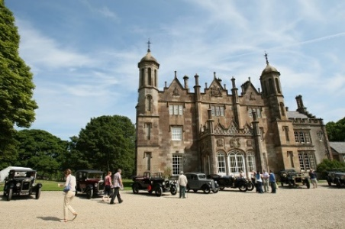
People say that Glenarm Castle is haunted.
Ljudi kažu da je dvorac Glenarm uklet.
It has had the same owners for 400 years.
Ima iste vlasnike već 400 godina.
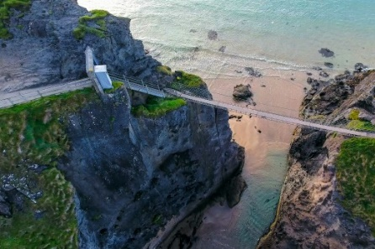
The Carrick-a-Rede Rope Bridge is a rope bridge.
Carrick-a-Rede Rope Bridge je most od užadi.
It connects the mainland and the small island.
Povezuje kopno i maleni otok.
Molly has heard it swings.
Molly je čula da se ljulja.
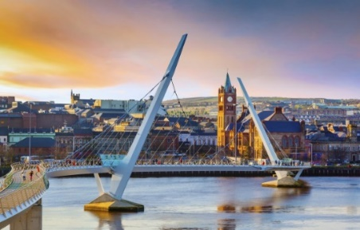
She wasn’t afraid to step on it.
Nije se bojala zakoračiti na njega.
Molly’s auntie lives in Londonderry.
Mollyna teta živi u Londonderryju.
She is taking Molly to see the Peace Bridge.
Ona vodi Molly u posjet Mostu mira.

b) Are the sentences correct? Circle True or False.
Jesu li rečenice točne? Zaokruži True (točno) ili False (netočno).

1 Molly has visited Londonderry alone.  Moly je sama posjetila Londonderry. | True | False
3 Molly’s granny lives there.  Mollyina baka živi tamo. | True | False
4 She has seen the Peace Bridge.  Vidjela je Most mira. | True | False
5 She wasn’t afraid to step on the rope bridge.  Nije se bojala zakoračiti na most od užadi. | True | False
6 Glenarm Castle has changed owners.  Dvorac Glenarm je promijenio vlasnike. | True | False
c) Match the tourist attraction with the correct picture.
Poveži turističku znamenitost s točnom slikom.
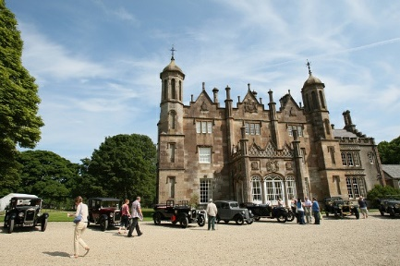

1 Carrick-a-Rede Rope Bridge

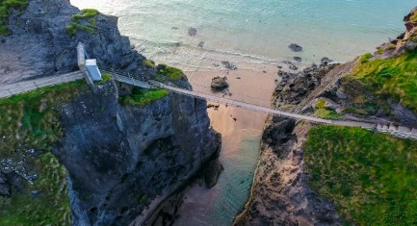

2 Glenarm Castle

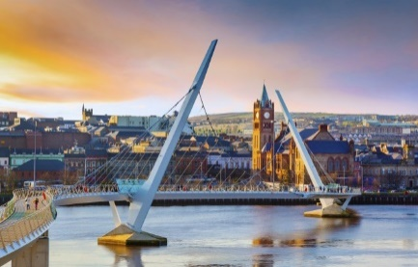

3 Peace Bridge

Read the text again. Then complete the sentences with the words from the box.
3
Ponovno pročitaj tekst. Zatim dopuni rečenice riječima iz kućice.
city swings aunt owners step
haunted mainland bridge has visited

Where has Molly been?
has visited
1 She ____________________________ Londonderry with her parents.
Ona je posjetila Londonderry sa svojim roditeljima.
2 Londonderry is the second largest _____________ in Northern Ireland.
Londonderry je drugi najveći grad u Sjevernoj Irskoj.
3 People say that Glenarm Castle is ___________________________.
Ljudi kažu da je dvorac Glenarm uklet.
4 It has had the same _____________________________ for 400 years.
Ima iste vlasnike već 400 godina.
5 Carrick-a-Rede Rope Bridge is a rope __________________________.
Carrick-a-Rede Rope Bridge je most od užadi.
6 It connects the _____________________________ and the small island.
Spaja kopno i maleni otok.
7 Molly has heard it __________________________________________.
Molly je čula da se ljulja.
8 She wasn’t afraid to _____________________________________ on it.
Nije se bojala zakoračiti na njega.
9 Molly’s ___________________________________ lives in Londonderry.
Mollyna teta živi u Londonderryju.

GRAMMAR!
My…
PRESENT PERFECT SIMPLE – SINCE and FOR

LOOK AND READ!
POGLEDAJ I PROČITAJ!
Riječ SINCE koristimo kada želimo reći od kada nešto traje.
They have been friends since 2014.  Oni su prijatelji od 2014. | Peter has travelled since he was a baby.  Peter putuje otkad je bio beba.
Riječ FOR koristimo kada želimo reći koliko dugo nešto traje.

They have been friends for 6 years.  Oni su prijatelji već 6 godina. | Peter has travelled for 20 years.  Peter putuje već 20 godina.

a) Sort the words. Write them under SINCE or FOR.
4
Razvrstaj riječi. Napiši ih ispod SINCE ili FOR.

two months | 1620 | September | a long time
dva mjeseca | 1620. godine | rujna | dugo vremena
birthday | 400 years | five years | 1995
rođendana | 400 godina | pet godina | 1995. godine
SINCE |  | FOR
1 __________________________ |  | 1 __________________________
2 __________________________ |  | 2 __________________________
3 __________________________ |  | 3 __________________________
4 __________________________ |  | 4 __________________________

b) Complete the sentences. Circle since or for.
Dopuni rečenice. Zaokruži since ili for.

1 The castle has been in the family since / for 400 years.
Dvorac je u obitelji 400 godina.
2 The castle has been in the family since / for 1620.
Dvorac je u obitelji od 1620.
3 We haven’t seen auntie since / for September.
Nismo vidjele tetu od rujna.
4 We haven’t seen auntie since / for two months.
Nismo vidjele tetu dva mjeseca.
5 She has lived in Londonderry since / for a long time.
Ona živi u Londnderryju dugo vremena.
6 She has lived in Londonderry since / for 1995.
Ona živi u Londonderryju od 1995.
7 They have been friends since / for five years.
Oni su prijatelji pet godina.
8 They have been friends since / for her birthday.
Oni su prijatelji od njenog rođendana.

What about you? Complete the sentences. Write what is true for you.
55
A ti? Dopuni rečenice. Napiši što je točno za tebe.

1 a) I have been at school since ________________________ o’clock.
(u koliko sati si došao / došla u školu?)
U školi sam od … sati.
b) I have been at school for __________________________ hours.
(koliko sati si već u školi?)
U školi sam … sati.

2 a) I have lived in my house since ____________________________.
(od koje godine živiš u svojoj kući?)
Živim u svojoj kući od…
b) I have lived in my house for _________________________ years.
(koliko godina živiš u svojoj kući?)
Živim u svojoj kući … godina.

3 a) I haven’t visited my granny since ___________________________.
(od kojeg dana / mjeseca / godine nisi
posjetio / posjetila svoju baku?)
Nisam posjetio / posjetila svoju baku od…
b) I haven’t visited my granny for_________________________ days.
(koliko je dana prošlo od kada si zadnji
put posjetio / posjetila baku?)
Nisam posjetio / posjetila svoju baku … dana.

