

10

**a) Look at the words and the picture. Repeat the words after your teacher or   
 your friend. Then copy the words in English on the lines.**

Pogledaj riječi i sliku. Ponovi riječi za učiteljicom ili prijateljem / prijateljicom. Zatim prepiši engleske riječi na crte.

|  |  |  |
| --- | --- | --- |
| 1 whale | _____________________ | kit |
| 2 blowhole | _____________________ | otvor za disanje |
| 3 flipper | _____________________ | peraja |
| 4 fluke | _____________________ | rep |
| 5 pod | _____________________ | jato kitova |
| 6 bull | _____________________ | mužjak kita |
| 7 cow | _____________________ | ženka kita |
| 8 calf | _____________________ | mladunče kita |

**5**

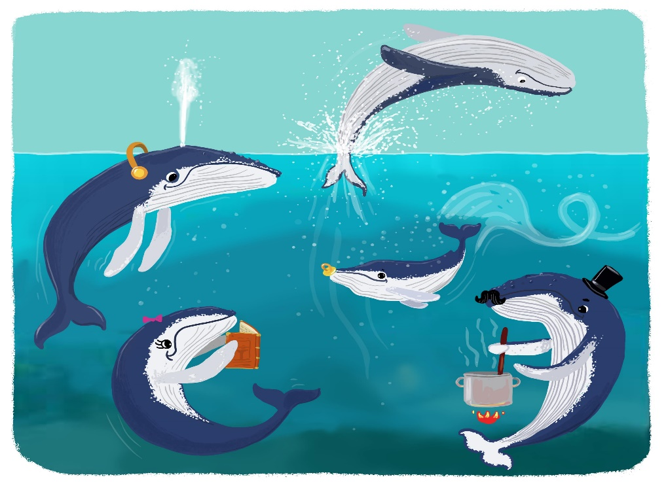

**3**

**4**

**2**

**1**

**6**

**7**

**8**

**b) Translate the words into English.**

1



Prevedi riječi na engleski jezik.

flipper

|  |  |
| --- | --- |
| 1 peraja | _____________________________ |
| 2 kit | _____________________________ |
| 3 mužjak kita | _____________________________ |
| 4 otvor za disanje | _____________________________ |
| 5 rep | _____________________________ |
| 6 jato kitova | _____________________________ |
| 7 ženka kita | _____________________________ |
| 8 mladunče kita | _____________________________ |



2

**a) Match the words in English with the words in Croatian.**



Poveži riječi na engleskome jeziku s riječima na hrvatskome jeziku.

|  |  |
| --- | --- |
| 1 mammal | disati |
| 2 drown  1 | sisavac |
| 3 breathe | utopiti se |

**b) Translate the words into English. Exercise 2 a) can help you.**



Prevedi riječi na engleski jezik. Zadatak 2. a) može ti pomoći.

drown

|  |  |
| --- | --- |
| 1 utopiti se | _____________________________ |
| 2 disati | _____________________________ |
| 3 sisavac | _____________________________ |

**Complete the sentences with words and phrases from Exercises 1 a) and 2 a). The sentences in Croatian can help you. Be careful: you will have to use the plural form of some words.**



3

Dopuni rečenice riječima i izrazima iz zadataka 1. a) i 2. a). Rečenice na hrvatskom mogu ti pomoći. Pazi: morat ćeš upotrijebiti množinu nekih riječi.

whales

1 Kaikoura is a place in New Zealand. You can watch __________ there.

Kaikoura je mjesto na Novom Zelandu. Tamo možeš gledati **kitove**.

2 You can learn a lot about this sea ______________.

Možeš mnogo naučiti o ovom **morskom sisavcu**.

3 You can also see a ______________.

Možeš vidjeti i **mladunče kita**.

4 It can swim because of its beautiful ______________.

Može plivati zahvaljujući svojim prekrasnim **perajama**.

5 It has got a______________ on top of its head.

Ima **otvor za disanje** na vrhu glave**.**

6 Whales need to ______________, too.

I kitovi trebaju **disati**.

7 Whales can ______________ if they forget to breathe.

Kitovi se mogu **utopiti** ako zaborave disati.

8 A group of whales is called a ______________.

Skupina kitova zove se **jato**.

**Comparative form of adjectives**

Komparativ pridjeva

GRAMMAR!

My…

|  |
| --- |
| LOOK AND READ!  POGLEDAJ I PROČITAJ! |
| Kratki pridjevi (tall, small, strong, big…) dobivaju nastavak **–er.** |
| A giraffe is **taller than** a zebra.  Žirafa je viša **od** zebre.  A mouse is **smaller than** a koala.  Miš je manji **od** koale. |
| Ispred dugih pridjeva (interesting, dangerous…) pišemo riječ **more**. |
| A lion is **more** dangerous **than** a zebra.  Lav je opasniji **od** zebre. |

|  |
| --- |
| LET’S REMEMBER!  PRISJETIMO SE! |
| Ako pridjev završava na –e, za tvorbu komparativa mu dodajemo još samo –r. |
| cute 🡪 cuter  large 🡪 larger |
| Ako pridjev završava na samoglasnik i suglasnik, za tvorbu komparativa mu udvostručujemo zadnji suglasnik te dodamo nastavak –er. |
| big 🡪 bigger  wet 🡪 wetter |
| Ako pridjev završava na suglasnik i –y, tada se –y mijenja u slovo –i. Zatim mu dodajemo nastavak –er za tvorbu komparativa. |
| heavy 🡪 heavier  lazy 🡪 lazier |

**a) Circle the correct answer: a) or b).**



4

Zaokruži točan odgovor: a) ili b).

1 **a)** A cheetah is **faster than** a turtle.

**b)** A cheetah is **faster then** a turtle.

2 **a)** An elephant is **heavyer than** a mouse.

**b)** An elephant is **heavier than** a mouse.

3 **a)** A cat is **cuteer than** a snake.

**b)** A cat is **cuter than** a snake.

4 **a)** A horse is **bigger than** a dog.

**b)** A horse is **biger than** a dog.

5 **a)** A lion is **dangerouser than** a zebra.

**b)** A lion is **more dangerous** than a zebra.

**b) Write sentences. Use the comparative forms of the adjectives in the brackets.**



Napiši rečenice. Koristi komparative pridjeva u zagradama.

faster

1 A cheetah is ________________ (fast) than a turtle.

Gepard je **brži** od kornjače.

2 A giraffe is ________________ (tall) than a zebra.

Žirafa je **viša** od zebre.

3 A dog is ________________ (loud) than a cat.

Pas je **glasniji** od mačke.

more intelligent

4 A chimpanzee is ________________________ (intelligent) than a horse.

Čimpanza je **inteligentnija** od konja.

5 A lion is ________________________ (dangerous) than a zebra.

Lav je **opasniji** od zebre.

**Superlative form of adjectives**

Superlativ pridjeva

GRAMMAR!

My…

|  |
| --- |
| LOOK AND READ!  POGLEDAJ I PROČITAJ! |
| Ispred kratkih pridjeva (long, fast, warm…) pišemo **the**, a iza nastavak  **–est**. |
| A cheetah is **the** fast**est** animal.  Gepard je najbrža životinja.  Pythons are **the** long**est** snakes.  Pitoni su najdužeživotinje. |
| Ispred dugih pridjeva (beautiful, interesting, difficult…) samo napišemo **the most**. |
| A peacock is **the most beautiful** animal.  Paun je najljepša životinja. |

|  |
| --- |
| LET’S REMEMBER!  PRISJETIMO SE! |
| Ako pridjev završava na –e, za tvorbu superlativa mu dodajemo još samo –st. |
| cute 🡪 the cutest  large 🡪 the largest |
| Ako pridjev završava na samoglasnik i suglasnik, za tvorbu superlativa mu udvostručujemo zadnji suglasnik te dodamo nastavak –est. |
| big 🡪 the biggest  wet 🡪 the wettest |
| Ako pridjev završava na suglasnik i –y, tada se –y mijenja u slovo –i. Zatim mu dodajemo nastavak –est za tvorbu superlativa. |
| heavy 🡪 the heaviest  lazy 🡪 the laziest |

**Circle the correct answer: a) or b).**

5



Zaokruži točan odgovor: a) ili b).

1 **a)** The fin whale is **the fastest** whale. *Zaokružiti a*

**b)** The fin whale is **the more fastest** whale.

2 **a)** The blue whale is **the bigest** animal.

**b)** The blue whale is **the biggest** animal.

3 **a)** The blue whale is **the heaviest** of all animals.

**b)** The blue whale is **the heavyest** of all animals.

4 **a)** The fin whale pees **the largeest** amount of urine.

**b)** The fin whale pees **the largest** amount of urine.

5 **a)** The orca is **the most intelligentest** of all whales.

**b)** The orca is **the most intelligent** of all whales.



688888

**a) Complete the table with the comparative and superlative forms of the adjectives.**



Dopuni tablicu komparativima i superlativima pridjeva.

the smallest

|  |  |  |
| --- | --- | --- |
| 1 small  malen | smaller  manji | _________________________  najmanji |
| 2 loud  glasan | loud___  glasniji | _________________________  najglasniji |
| 3 big  velik | __________  veći | _________________________  najveći |
| 4 heavy  težak | __________  teži | _________________________  najteži  the most intelligent |
| 5 intelligent  inteligentan | ________________  inteligentniji  more ancient | _________________________  najinteligentniji |
| 6 ancient  star | ________________  stariji | _________________________  najstariji |

**b) Read the sentences. Complete them with the comparative or superlative forms   
 of the adjectives in brackets.**



Pročitaj rečenice. Dopuni ih komparativima ili superlativima pridjeva u zagradi.

the most ancient

1 Yellow-eyed penguins are ________________ (ancient) of all living penguins.

Žutooki pingvini su **najstariji** od svih živućih pingvina.

2 They are ________________ (rare) penguin species in the world.

Oni su **najrjeđa** vrsta pingvina na svijetu.

3 Male penguins live ________________ (long) than female penguins.

Mužjaci žive **duže** od ženki.

4 Tuataras are ________________ (old) living reptiles in the world.

Premosnici su **najstariji** živući gmazovi na svijetu.

5 They are ________________ (large) reptiles in New Zealand.

Oni su **najveći** gmazovi na Novom Zelandu.

6 They have ________________ (low) body temperature than other reptiles.

Oni imaju **nižu** tjelesnu temperature od ostalih gmazova.

7 They have ________________ (slow) metabolism than other reptiles.

Oni imaju **sporiji** metabolizam od ostalih gmazova.

8 They can live ________________ (long) than other reptiles.

Oni mogu živjeti **duže** od ostalih gmazova.

9 Kakapos are ________________ (strange) parrots in the world.

Kakapo papige su **najčudnije** papige na svijetu.

10 They have got ________________ (strong) legs than other parrots.

Imaju **jače** noge od drugih papiga.

11 They are ________________ (heavy) than other parrots.

One su **teže** od drugih papiga.