A balanced diet
- eat different kinds of food
- eat the right amounts of food
- include five groups of food
- fruit and vegetables 50%, rich in vitamins and minerals
- protein 25%
- grains and dairy 25%, rich in calcium and protein
- eat enough fish, sea food
- eat lean meat (beef and chicken)
- eat whole grain products (brown bread, brown rice)

Fruit and vegetables 50% Protein 25%
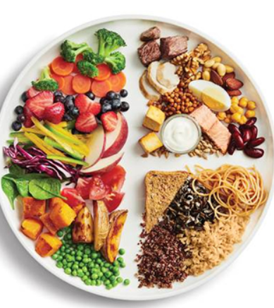
Grains and dairy 25%
-If you want to be healthy, you should eat …
-Don’t skip breakfast because …
-Try to eat …
-You should also …
-You shouldn't forget to …
SPEAKING TIPS
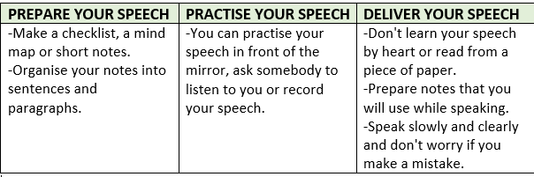

Govorenje: samovrednovanje
Balanced diet | 👍 | 👎
Pravilno izgovaram i naglašavam riječi i točno intoniram rečenice.
Govorim tečno i bez čestih zastajkivanja.
Koristim širok raspon riječi i nove riječi.
Koristim točan poredak riječi u rečenici i poštujem gramatička pravila: Present Simple / Present Continuous / komparaciju pridjeva i množinu imenica.
Opisujem sve važne karakteristike zdrave prehrane.
Svaka je rečenica razumljiva.

