The North Coast
Fact file
Glenarm Castle | Carrick-a-Rede Rope Bridge | Peace Bridge
-has been in McDonnell family for 400 hundred years  -haunted | -joins the mainland and Carrickarede  -has been there for 350 years  -it swings | -opened in 2011  -it brought together two political blocks in Derry  -a symbolical handshake across the River Foyle

Derry (Londonderry)
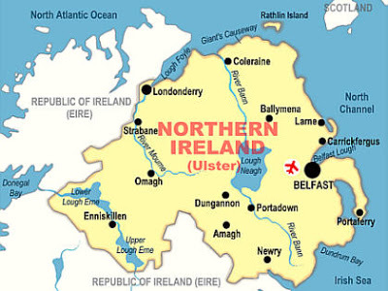
The River Foyle
